

Mololuwa Obafemi-Moses

U2130433

**Human Activity Recognition using publicly available accelerometer dataset for Support Vector Machine Technique**

May 10th, 2022.

# Acknowledgment

This dissertation would not have been feasible without the advice and assistance of numerous people who contributed and extended their important support in the preparation and completion of this study in various ways.

My sincere thanks to my supervisor Dr. Seyed Ali Ghorashi for the encouragement and support throughout my dissertation completion.

I also thank God and my family for their support throughout my completion of the dissertation.

# Abstract

Human activity recognition using an accelerometer-based sensor is important in a variety of applications, including public healthcare rehabilitation, monitoring, and physical conditioning. The majority of human activity recognition accelerometer-based data sets from free-living environments have non-fixed sensor placements, and inconsistent annotations. In this study, I present a human activity recognition dataset referred to as the Human Activity Recognition Trondheim dataset (HARTH) which is a publicly available dataset that is placement-dependent, accelerometer-dependent, and expertly annotated dataset carried out by participants in a free-living condition. The information from the two three-axial accelerometers is included in the dataset. The measurement is also associated with different reported physical activities: walking, running, stairs(ascending), stairs(descending), Standing, sitting, lying, cycling(sitting), and cycling(standing). This paper also uses a support vector machine model to run some preliminary tests on the datasets. Considering the dataset was derived from using an actual accelerometer sensor, unlike previous datasets, developing a good model on such data remains an open subject and a challenge for researchers. It is possible to bridge the gap between the model and a real-world application by doing so.

Table of Contents

[Acknowledgment 2](#_Toc103059128)

[Abstract 3](#_Toc103059129)

[Chapter One 7](#_Toc103059130)

[Background 7](#_Toc103059131)

[Objective 8](#_Toc103059132)

[Structure of thesis 8](#_Toc103059133)

[Chapter Two 9](#_Toc103059134)

[Introduction 9](#_Toc103059135)

[Conclusion of Theoretical Analysis 16](#_Toc103059136)

[Chapter Three 17](#_Toc103059137)

[Introduction 17](#_Toc103059138)

[Dataset 17](#_Toc103059139)

[Feature Extraction and Feature Selection 19](#_Toc103059140)

[Classification 19](#_Toc103059141)

[Binary Classification SVM 20](#_Toc103059142)

[Multi-Class SVM 20](#_Toc103059143)

[Advantages associated with SVM 21](#_Toc103059144)

[Implementing SVM in Python 21](#_Toc103059145)

[Chapter Four 22](#_Toc103059146)

[Performance Analysis 22](#_Toc103059147)

[Experimental Result 23](#_Toc103059148)

[Hyperparameter Analysis. 24](#_Toc103059149)

[For C = 1 and Gamma = scale. 24](#_Toc103059150)

[For C = 10 and Gamma = scale. 25](#_Toc103059151)

[For C = 100 and Gamma = scale. 27](#_Toc103059152)

[For C = 1000 and Gamma = scale 28](#_Toc103059153)

[For C = 1 and Gamma = 0.001 29](#_Toc103059154)

[For C = 10 and Gamma = 0.001 31](#_Toc103059155)

[For C = 100 and Gamma = 0.001 32](#_Toc103059156)

[For C = 1000 and Gamma = 0.001 34](#_Toc103059157)

[For C = 1 and Gamma = 0.0001 35](#_Toc103059158)

[For C = 10 and Gamma = 0.0001 37](#_Toc103059159)

[For C = 100 and Gamma = 0.0001 38](#_Toc103059160)

[For C = 1000 and Gamma = 0.0001 40](#_Toc103059161)

[Performance summary 41](#_Toc103059162)

[Discussion 42](#_Toc103059163)

[Comparison with Previous work 43](#_Toc103059164)

[Chapter Five 43](#_Toc103059165)

[Conclusion 43](#_Toc103059166)

[Reference 44](#_Toc103059167)

[Appendix 48](#_Toc103059168)

**List of Figures**

[**Figure 1.** This figure shows the five steps in preprocessing performed on the data used in this project. 17](#_Toc103059257)

[**Figure 2** This figure shows the placement of the two sensors located on the back and thigh of the participant. The sensor on the lower back is placed on the 3rd lumbar vertebra and the sensor on the thigh is placed 10cm above the kneecap 18](#_Toc103059258)

[**Figure 3** This figure shows the count and labels of the HARTH dataset. The label indicates the activities carried out and the count indicates the number of activities present in each set 23](#_Toc103059259)

[**Figure 4** This figure shows the Confusion matrix of the data with C=1 and gamma=scale 24](#_Toc103059260)

[**Figure 5** The figure above shows the Classification report for the SVM RBF model, C=1 24](#_Toc103059261)

[**Figure 6** This figure shows the Confusion matrix of the data with C=10 and gamma=scale 25](#_Toc103059262)

[**Figure 7** The figure above shows the Classification report for the SVM RBF model, C=10 26](#_Toc103059263)

[**Figure 8** This figure shows the Confusion matrix of the data with C=100 and gamma=scale 26](#_Toc103059264)

[**Figure 9** The figure above shows the Classification report for the SVM RBF model, C=100. 27](#_Toc103059265)

[**Figure 10** This figure shows the Confusion matrix of the data with C=1000 and gamma=scale 28](#_Toc103059266)

[**Figure 11** The figure above shows the Classification report for the SVM RBF model, C=1000. 28](#_Toc103059267)

[**Figure 12** This figure shows the Confusion matrix of the data with C=1 and gamma=0.001 29](#_Toc103059268)

[**Figure 13** The figure above shows the Classification report for the SVM RBF model, C=1, gamma=0.001 30](#_Toc103059269)

[**Figure 14** This figure shows the Confusion matrix of the data with C=10 and gamma=0.001 30](#_Toc103059270)

[**Figure 15** The figure above shows the Classification report for the SVM RBF model, C=10, gamma=0.001. 31](#_Toc103059271)

[**Figure 16** This figure shows the Confusion matrix of the data with C=100 and gamma=0.001 32](#_Toc103059272)

[**Figure 17** The figure above shows the Classification report for the SVM RBF model, C=100, gamma=0.001. 32](#_Toc103059273)

[**Figure 18** This figure shows the Confusion matrix of the data with C=1000 and gamma=0.001 34](#_Toc103059274)

[**Figure 19** The figure above shows the Classification report for the SVM RBF model, C=1000, gamma=0.001. 34](#_Toc103059275)

[**Figure 20** This figure shows the Confusion matrix of the data with C=1 and gamma=0.0001 35](#_Toc103059276)

[**Figure 21** The figure above shows the Classification report for the SVM RBF model, C=1, gamma=0.0001 36](#_Toc103059277)

[**Figure 22** This figure shows the Confusion matrix of the data with C=10 and gamma=0.0001 37](#_Toc103059278)

[**Figure 23** The figure above shows the Classification report for the SVM RBF model, C=10, gamma=0.0001 37](#_Toc103059279)

[**Figure 24** This figure shows the Confusion matrix of the data with C=100 and gamma=0.0001 38](#_Toc103059280)

[**Figure 25** The figure above shows the Classification report for the SVM RBF model, C=100, gamma=0.0001 39](#_Toc103059281)

[**Figure 26** This figure shows the Confusion matrix of the data with C=1000 and gamma=0.0001 40](#_Toc103059282)

[**Figure 27** The figure above shows the Classification report for the SVM RBF model, C=1000, gamma=0.0001 40](#_Toc103059283)

[**Figure 28** . The figure above shows the accuracy distribution of the hyperparameter C and gamma. 41](#_Toc103059284)

[**Figure 29** This figure shows the distribution of Recognition Rate of Sitting 42](#_Toc103059285)

**List of Tables**

[**Table 1.** This table shows the details of the Publicly available dataset used for HAR accelerometer-based research; it also includes the HARTH dataset used to carry out the experiment in this project. PAs refer to the number of Physical Activities. 11](#_Toc103059206)

[**Table 2.** This Table shows the details of the research investigated, classification models used, number of accelerometers used, number of activities carried out, total number of participants and the accuracy of each model used. 14](#_Toc103059207)

[**Table 3** The table shows a comparison between the datasets analyzed in the project and the dataset used in the research. 16](#_Toc103059208)

[**Table 4** This table shows the interpretation of each label number in direct correlation with the activities. 24](#_Toc103059209)

[**Table 5** The accuracy achieved for each kernel C, γ, and degree hyperparameters. The best result is highlighted in bold. 41](#_Toc103059210)

[**Table 6** This Table shows the recognition rate for sitting with various Hyperparameters. 41](#_Toc103059211)

# **Chapter One**

Human Activity Recognition using publicly available accelerometer dataset for Support Vector Machine Technique

## Background

Human Activity Recognition (HAR) is rapidly becoming an important aspect of ubiquitous computing. The use of sensor data also plays a key role in monitoring and recognizing specific human activities (Twomey et al., 2018, p.27). Physical activity behavior affects public health (Lee et al., 2012, p.219-229). However, previously undergone research investigating physical activity more often than not rely on self-reporting data, which can be biased, misclassified, and unreliable (Pedersen et al., 2016, p.836). Human activity recognition (HAR) is a branch of research that focuses on identifying distinct human physical activities and postures using sensor data (Yang et al., 2011, p.239-246). Because of their low cost and small size, body-worn accelerometers are frequently utilized for various data collection techniques for HAR (Demrozi et al, 2020). In the last decade, machine learning approaches have commonly been used as a way of classifying sensor data for HAR.

Several HAR studies have accurately measured and tested various physical activity behavior in a free-living environment on self-recorded datasets using various machine learning approaches, however, these datasets are not publicly available (Demrozi et al, 2020; Micucci et al, 2017; Reiss, 2017; Lara, 2013).

Furthermore, most HAR-based physical activity behavior research and machine learning analyses are carried out in the laboratory (De Almeida et al., 2018, p.98-110). While studies have shown that the machine learning analysis of physical activity behavior generated from the laboratory demonstrated a lower accuracy and performance when tested in a free-living environment (Narayanan, 2020; Ahmadi et al, 2020; Ahmadi et al, 2020; Cuba, 2011). Just a few investigations have been carried out in free-living environments, in which individuals are free to engage in everyday activities but must complete specific preset tasks at least once and fewer yet have looked at data from two accelerometers (Stewart et al, 2020; Narayanan et al, 2017; De Almeida et al, 2014), in as much various studies have concluded that an increase in the number of accelerometers will improve the classification performance. The major challenge in this process is the association of the trustworthiness of the activity annotations in current free-living datasets, as relevant articles and experiments do not mention the annotation method's dependability.

It is therefore impossible to have a comparison between these machine learning analysis approaches considering that the datasets are not publicly available and the research conducted in a controlled environment.

The dataset considered in this experiment is the Human Activity Recognition Trondheim Dataset “HARTH”. The term “HARTH” is gotten from the name of the location the dataset was recorded in Trondheim. During their usual working hours, twenty-two individuals engaged in a variety of tasks while going about their daily routines as naturally as possible. A total of twelve actions were annotated by two specialists.

The experiment indicated the location of the wearable sensor and the type of sensor employed was a tri-axial Axivity AX3 accelerometer sensor, which was positioned on the thigh and lower back, while the verification was carried out by experts on the annotated data (Logacjov et al., 2021, p.60) The data is publicly available at [**https://github.com/ntnu-ai-lab/harth-ml-experiments**](https://github.com/ntnu-ai-lab/harth-ml-experiments)**.**

## Objective

The purpose of this project is therefore to use the Support Vector Machine (SVM) model which is a machine learning approach to analyze HARTH which is a publicly available dataset with participants of the Human Activity Recognition performing various physical activities behavior in a free-living environment as naturally as possible with an expertly annotated activities dataset. The SVM model will help predict the labels and the performance of various activities which were carried out using the specific dataset.

The evaluation of this Data set using the Support Vector Machine model would result in providing a better insight into the accuracy of classification model training for the HARTH dataset and further improve health studies concerning physical activities in the future.

## Structure of thesis

The appropriate literature linked to the topic just outlined will be discussed in Chapter 2. The research approach used to address the topic will be described and discussed in Chapter 3. The data acquired using the approach provided in chapter three will be presented and analyzed in chapter four. The investigation will come to a close with chapter five, which contains a summary and conclusions taken from the data presented in chapter four, as well as recommendations based on the findings of this study and suggestions for future research.

# **Chapter Two**

## Introduction

Human Activity Recognition (HAR) is a hot topic in science right now with a lot of active research. A wealth of literature exists for recognizing activities such as sitting, standing, running, and walking utilizing body-worn (wearable) sensors such as accelerometers and gyroscopes. The availability of a few publicly available datasets in Human Activity Recognition research which also contains samples from subjects with similar characteristics makes it challenging to determine a subset of samples for machine learning analysis (Micucci et al, 2017). Demorazi et al, confirmed that 30 of 142 accelerometer-based datasets in a recent survey (Demrozi et al., 2020, p.8) were available, with the main problem being that only a handful of the datasets were captured in a free-living context.

The Sussex-Huawei Locomotion (SHL) dataset (Wang et al., 2019, p.7) had three participants engaging in eight activities in a free-living setting over a seven months period. The transportation activities included staying still, running, walking, biking, using a bus, using the train, driving a car, and standing in the subway. 16 smartphone sensors were attached to each participant recording a multimodal dataset which was annotated using one smartphone and amounted up to 2800 hours. The dataset is publicly available at [**http://www.shl-dataset.org**](http://www.shl-dataset.org) (accessed on 24 February 2022). The participants were allowed to execute ordinary physical activities, and the dataset included four physical activities: walking, cycling, running, and sitting/standing. The transportation action of "staying stationary" includes both sitting and standing, making it difficult to distinguish between the two.

The HASC-PAC2016 dataset (Ichino et al., 2016, p. 705-714) [**http://hub.hasc.jp/corpora**](http://hub.hasc.jp/corpora) (Accessed on 25 February 2022) is a publicly available resource that comprises previously published HASC-PAC datasets (Kawaguchi et al, 2011; Kawaguchi et al, 2012; Kaji et al, 2013). The experiment involved the recording of eighty-two participants performing six activities in a free-living setting within a defined geographical location. The activities included walking, skipping, walking the stairs, running, and no activity (which included standing, sitting, and lying). To achieve this data was collected using a smartphone accelerometer, and annotations were made using an app.. The location of the wearable sensors was not included in the report and the smartphone manufacturing details were also not stated.

An orientation-independent, placement-independent, and subject-independent Real-Life-HAR dataset were proposed by Garcia-Gonzalez et al (2020, p.20). The data is publicly available at [**http://lbd.udc.es/research/real-life-HAR-dataset**](http://lbd.udc.es/research/real-life-HAR-dataset) (Accessed on 25 February 2022). The experiment conducted included Nineteen participants performing four activities in their everyday life. The activities registered included walking, driving, active and inactive. The annotations were done by the participants and a smartphone accelerometer sensor was used as the data collection tool.

The Wireless Sensor Data Mining (WISDMv2.0) smartphone-based sensor dataset (Lockhart et al., 2011, p. 25-33; Weiss, 2012), [**https://www.cis.fordham.edu/wisdm/dataset.php#actitracker**](https://www.cis.fordham.edu/wisdm/dataset.php#actitracker)

(Accessed on 25 February 2022) which is a publicly available resource. The experiment focused on the evaluation of personal and impersonal activity recognition models. The data was collected using fifty-nine participants carrying an android-based smartphone in their pocket while carrying out their everyday activities. The participants carried out six activities which include walking, jogging, sitting, standing, and lying. The annotation was also carried out by the participants using a sensor collection application with fifteen different smartphones being used to collect the data.

The Dailylog dataset (Sztyler et al., 2016, p 160-180) recorded several activities during several days from seven participants in their everyday routine. The annotations were done by the participants while an introduction and guideline were explained to them to avoid them choosing a different label in the same situation. The data was collected using a smartphone and a smartwatch. The smartphone was placed in the pocket of the participant while the smartwatch was placed on the wrist. 12 activities were evaluated and 33-subactivities. Higher-level activities such as eating and playing sports were also examined. The data set [**https://sensor.informatik.uni-mannheim.de/#dataset\_dailylog**](https://sensor.informatik.uni-mannheim.de/#dataset_dailylog) (Accessed on 25 February 2022) is a publicly available resource.

The TMD dataset (Carpineti et al.,2018, p 367-372) investigated the theoretical possibility of the use of smartphones to identity mobility by the use of acquired data from smartphones. The experiment recorded 13 participants using a mobile phone to detect various physical exercises. The physical exercises that were evaluated included standing, walking, and sitting (this was done in a car). Multiple modalities, including acceleration, were recorded using smartphone sensors. During their physical activities, the 13 participants utilized a smartphone app to classify and annotate the data. The dataset [**http://cs.unibo.it/projects/us-tm2017**](http://cs.unibo.it/projects/us-tm2017) (Accessed on 13 April 2022) is a publicly available resource.

The Student Living Dataset commonly referred to as SDL was created by Herrera-Alcántara et al 2019, p19). The aim of the experiment was to contribute to the research of students' every day activities by assuming that there were correlations between their academic achievement and their habits, as well as between their actions and sensor signals from wristwatch devices. The students used a smartphone app to conduct the annotations. Eating, jogging, resting, classroom sessions, exams, jobs, homework, commuting, watching TV (series), and reading are among the activities that were evaluated during the experiment.

This dataset is currently only available to the respective authors upon request.

Even though classification performance can be enhanced by investigating more than one accelerometer, few HAR research articles do so (Fullerton et al, 2017; Narayanan et al, 2020; Cleland et al, 2013; Olguin et al, 2006). In this literature review, I am demonstrating analogous HAR efforts based on machine learning that look at more than one accelerometer but don't require any other sensors (e.g., gyroscopes).

|  |  |  |  |  |  |  |
| --- | --- | --- | --- | --- | --- | --- |
| Dataset | Number of Labels | Number of PAs | Number of Subjects | Number of Accelerometer | Sensor Type | Annotation |
| Sussex-Huawei Locomotion (SHL) | 4 | 2 | 19 | 1 | Smartphone | User and Expert |
| HASC-PAC2016 | 6 | 6 | 81 | 1 | Smartphone | User |
| Real-Life-HAR | 4 | 2 | 19 | 1 | Smartphone | User |
| Wireless Sensor Data Mining (WISDMv2.0) | 6 | 6 | 225 | 1 | Smartphone | User |
| Daily log | 19 | 7 | 7 | 2 | Smartphone | User |
| TMD | 5 | 3 | 13 | 1 | Smartphone | User |
| Student Daily Living | 10 | 4 | 8 | 1 | Smartwatch | User |
| HARTH | 12 | 9 | 22 | 2 | Axivity AX3 | Human experts |

**Table 1.** This table shows the details of the Publicly available dataset used for HAR accelerometer-based research; it also includes the HARTH dataset used to carry out the experiment in this project. PAs refer to the number of Physical Activities.

Stewart et al used 75 participants (42 children, 33 adults) who were recorded in the lab while using two Axivity AX3 (Axivity Ltd., Newcastle, UK) accelerometers sensor positioned on the lower back and thigh to train a Random Forest classifier. Standing, Sitting, slow walking, lying, quick walking, and running were identified with a balanced accuracy of 97.3 percent for children and 99.1 percent for adults for the six activities.

A similar investigation was conducted by Narayanan et al, 2020. The free-living data of 30 people (15 children, 15 adults) who wore the identical AX3 accelerometers on their thigh, lower back, and wrist were recorded. Using a Random Forest classifier, the thigh and lower back combination produced the greatest balanced accuracy of 95.6 percent (adults) and 92 percent (children) after several sensor position combinations were tested.

A recently conducted research on a system that gathers accelerometer data from a tri-axial accelerometer sensor coupled with a smartwatch to recognize and determine the fundamental human body motions (Fernando G. D Silva et al, 2013) Fisher Discriminant Ratio (FDR) and Principal Component Analysis (PCA) were used to pick the 19 and 21 most unique features from a collection of 31 characteristics, respectively.

K-nearest neighbors, Multilayer perceptron, and Support Vector Machine were used to classify the specified characteristics (SVM). The results of the experiments show that SVM outperforms K-nearest neighbors, with a classification accuracy of 93%.

In another study conducted by (Bao et al, 2004 p 1-17) five bi-axial accelerometers were worn on the non-dominant upper arm, right hip, dominant wrist, dominant ankle, and non-dominant thigh. by 20 volunteers who did 20 activities. The decision tree outperformed the other three classifiers when compared (84 percent). Regardless of the five accelerometers that created the best results, Bao and Intille (Bao et al, 2004 p 1-17) determined that for some activities it is sufficient to achieve optimal results with two sensors. Olguin and Pentland arrived at the same conclusion (Olguin et al, 2006 p 11-13). They utilized data from three accelerometer sensors to calculate acceleration which included the hip, chest and wrist. Utilizing the three resulted in the highest accuracy (92.1 percent), although using just two might get comparable outcomes (87.2%) wrist, hip. Ahmadi et al (Ahmadi et al, 2020) looked into hip/wrist configurations as well. The authors used data for free-living conditions from pre-kindergarten children's activities to train a Random Forest classifier. The combined F-score of the hip and wrist accelerometers was higher than the F-score of the two sensors separately. For data collection, utilizing a smartphone and wristwatch, and to detect seven activities, (Shoaib et al, 2015 p591-596) a classification model for an SVM, a k-NN, and a decision tree was employed. For some actions, the integration of both sensors surpassed the individual sensors. In another experiment, (Gao et al, 2014 p779-785) demonstrated that each sensor performed better than a combination of the chest, side, thigh, and waist-mounted accelerometers independently by using four different classifiers:  SVM, k-NN, decision tree, and naive Bayes. Seven machine learning models were used to identify seven activities: decision tree, SVM, naive Bayes, RF, k-NN Bayesian network, and logistic regression, with five smartphones located in the left trouser pocket, right trouser pocket, belt, right wrist, right upper arm which were utilized to collect data (Shoaib et al, 2014 p10146-10176). Nine accelerometers which were placed in the following position (spine, left/right ankle, left/right upper arm, left/right hip, left/right wrist) for six activities were predicted using a k-NN, a decision tree, an SVM, and an ensemble-bagged tree technique. With 97.6% accuracy, the k-NN model produced the best performance (Fullerton et al, 2017, p5290-5297). Another research looked at nine sensors and placed a sensor on one for each upper back and body limb training a decision tree, a k-NN, and a closest class center classifier. The k-NN classifier performed better than the others (Banos et al, 2012, p1026-1035). After recording with six bi-axial accelerometers a dataset and was trained using a Bayesian network, a k-NN, a naive Bayes, and a decision tree. Six participants took part in six different physical activities where each sensor position is examined individually. The decision tree produced the best acceleration-based results: 76.6% for the sensor located at the wrist, 79.5% for the sensor located at the pocket, 87.2% for the sensor located in the bag, 72.6% for the sensor positioned at the necklace, 78.0% for the sensor positioned at the shirt, and 77.2% for the sensor positioned at the belt (Maurer et al, 2006, p 4-116). Five activities were classified using an AdaBoost classifier and four accelerometers. In the research, to pick the 12 best characteristics for activity categorization, the best first selection approach was used, and the outcome had an overall weighted accuracy of 99.4% was the best performing outcome (Ugulino et al, 2012, p52-61). Another research carried out to train an AdaBoost classifier, and an RF, utilized the same dataset from a previous work done by Ugulino et al (Ugulino et al, 2012, p52-61). With a performance accuracy of 99.9%, an average recall of 99.8%, and a precision of 99.8%, the RF classifier surpassed the AdaBoost Classifier (Zubair et al, 2016, p1-5). Recent research suggested a model dataset with nine activities, researchers proposed an integrated temporal CNN with layering LSTM and contrasted it to three similar deep learning techniques. Three accelerometers were positioned on the backs of seven individuals to record the data. With an average accuracy of 99.77%, the suggested model surpassed the others (Gupta et al, 2021, p1-5).

The majority of the papers presented employed over two sensors, however as Bao and Intille (Bao et al, 2004, p1-17) and Olgun and Pentland (Olguin et al, 2006, p11-13) pointed out, this does not significantly enhance the HAR findings. Moreover, utilizing fewer sensors provides participants with a higher degree of comfort.

Human Activity recognition tasks can also be conducted using an autoregressive model from a tri-axial accelerometer data, and an introduction to an autoregressive model (AR) for human activity identification can be performed. AR coefficients were derived as characteristics for categorizing various activities including running, staying still, jumping, and walking. Using a Support vector machine classifier with a fivefold cross-validation approach, a recognition rate of 92.25% was attained (Zhen-Yu; Lian-Wen; 2008, vol.4).

|  |  |  |  |  |  |
| --- | --- | --- | --- | --- | --- |
| Researcher Investigated | Classification Model used | Number of accelerometers | Number of activities | Number of Participants | Model Accuracy (%) |
| Stewart et al, 2012. | Random Forest classifier | 2 | 7 | 75 | 97.3 |
| Narayanan et al, 2020 | Random Forest classifier | 2 | 7 | 30 | 95.6 |
| Fernando G. D Silva et al, 2013 | Support Vector Machine | 2 | 31 |  | 93 |
| Bao et al, 2004 | Decision tree | 5 | 20 | 20 | 84 |
| Olguin et al, 2006 | Random Forest classifier | 3 |  |  | 92.1 |
| Ahmadi et al, 2020 | Random Forest classifier | 2 | 5 | 13 | 86.3 |
| Shoaib et al, 2015 | Support Vector Machine, Decision Tree | 2 | 7 | 25 | 92 |
| Gao et al, 2014 | SVM, naive Bayes, RF, k-NN, and Bayesian network. | 4 | 6 | 18 | 91.3 |
| Shoaib et al, 2014 | Decision tree, SVM, naive Bayes, RF, k-NN Bayesian network, and logistic regression. | 5 | 7 | 30 | 88.4 |
| Fullerton et al, 2017 | k-NN | 9 | 6 | -  19 | 97.6 |
| Banos et al, 2012 | k-NN | 9 | 7 | 24 | 88.5 |
| Maurer et al, 2006 | Decision tree | 6 | 6 | 6 | 87.2 |
| Ugulino et al, 2012 | AdaBoost classifier | 4 | 5 | 4 | 99.4 |
| Zubair et al, 2016 | RF classifier | 4 | 5 | 8 | 99.8 |
| Gupta et al, 2021 | CNN | 3 | 9 | 7 | 99.77 |
| Zhen-Yu; Lian-Wen; 2008 | SVM | 1 | 4 | - | 92.25 |

**Table 2.** This table shows the details of the research investigated, classification models used, the number of accelerometers used, the number of activities carried out, the total number of participants, and the accuracy of each model used.

The table above provides a summary of the research papers reviewed in this project and the attributes and characteristics of each performance analysis in determining Human Activity Recognition.

Converting accelerometer data to a spherical coordinate system is another way of conducting an activity recognition process. Making it easy for the extraction of features from the modified data. A multilayer perceptron neural network with 48 hidden layers was given 36 generated characteristics with a sliding window technique, and 12 accelerometer data in spherical dimensions. The results show that 99.9% of the activities were correctly identified (Samad Zabihi et al, 2014, p237-240).

Using the principal component analysis approach in other to minimize dimensionality and choosing three features from a dataset of 12 features. Their findings show that data preparation (z-score scaling and 0–1 scaling) has a significant impact on accuracy and recall. Using SVM and K-mean classifiers and splitting the training set to 90% and testing data set to 10% resulted in increased precision and recall rate (Huafei Wang; Jennifer Wu; 2018)

A large number of studies on feature selection strategies for activity identification have also been carried out and are accessible in the literature. An examination into the developments in the field of feature selection studied several feature selection methods (filter, wrapper), and discussed the current concerns and challenges of feature selection in a major way (Tonchev Krasimir et al, 2015). Another research proposed a feature selection approach for the categorization of ten postures by grouping seven chosen characteristics into three categories. The data collected from 13 patients yielded a total of 9 characteristics, including raw data (Ax, Ay, Az), roll, Pitch, and change in acceleration (Shumei Zhang et al, 2014). Three subsets were organized in three distinct SVM models to create a hierarchal method. Their testing results show a considerable increase in accuracy (83.1%). Using a supervised learning technique. In order to attain the highest degree of accuracy, the author modeled an activity recognition chain (ARC) using a specific algorithm for improvement. Out of a total of 280 traits, the author selected 94 that were most important and categorized 12 separate activities. The C4.5 decision tree classifier and Random Forest classifier were utilized to classify the data, with a 94% accuracy rate (Baldominos Alejandro et al, 2015).

Using the Discrete Cosine Transform, Zhen Yu (Zhen Yu et al, 2009) built a single tri-axis accelerometer-based activity detection system (DCT). A multiple class support vector machine was used to classify four distinct activities including running, jumping, staying still, and walking with a total identification rate of 97.5%.

|  |  |  |
| --- | --- | --- |
| Research | Pros | Con |
| Sussex-Huawei Locomotion (SHL) | * Publicly available * Expertly Annotated | * Activities were difficult to distinguish. |
| HASC-PAC2016 | * Publicly available. * Free-living conditions. | * No details of accelerometer sensor placement. * No details on the type of smartphone used. |
| Real-Life-HAR | * Publicly available * Free-living conditions. | * Only two activities were considered. * No details about the sensor placement. |
| Wireless Sensor Data Mining (WISDMv2.0) | * Wide range of participants (323 users) * Publicly available * Free-living conditions | * Partly annotated. |
| Daily log | * Sensor placement data * Free-living conditions * Wide range of activities (19 activities and 33 sub activities). | * Annotated by participants. |
| TMD | * Focused on Transport mode detection. | * Annotated by participants. |
| Student Daily Living | * Free-living environment. * Accelerometer data was recorded using a smart watch. | * Annotated by participants * Not Publicly available. |
| HARTH | * Free-living conditions. * Accelerometer data was recorded using Axivity AX3 device. * Publicly available * Information on Sensor Placement * Expertly annotated. |  |

**Table 3** The table shows a comparison between the datasets analyzed in the project and the dataset used in the research.

The dataset discussed above has been presented with several limitations, firstly the data collection approach was done using a smartphone and, in most cases, the name or type of smartphone was not mentioned. Utilizing smartphones for SHM applications most especially for accelerometers has been seen to have a poor performance on the data because smartphones have low sensitivity as well as a relatively high output noise level Elhattab et al (2019, p.19). Secondly, the positions of the smartphones were in some cases not known while others were not fixed. The challenge that arises is poor performance in this case because the same activity might seem differently while processing the same signal, substantial intraclass variation can be resulted from performance analysis. Thirdly, the annotations for the publicly available datasets did not report any annotation reliability method this is since the participants were the ones annotating the labels. The overall efficiency to train a HAR data model can be affected if these limitations are properly addressed.

The dataset to be considered in this experiment is the Human Activity Recognition Trondheim Dataset “HARTH”. The term “HARTH” is gotten from the name of the location the dataset was recorded in Trondheim. The experiment indicated the location of the wearable sensor which is placed on the thigh and back, the kind of sensor which was used which was a tri-axial Axivity AX3 accelerometer, and the verification by experts on the annotated data (Logacjov et al., 2021, p.60) The data is publicly available at [**https://github.com/ntnu-ai-lab/harth-ml-experiments**](https://github.com/ntnu-ai-lab/harth-ml-experiments)**.**

## Conclusion of Theoretical Analysis

When it comes to classifying certain activities, several classifiers are more accurate than others. For basic activities like sitting and standing, a decision tree may achieve maximum accuracy, while Support Vector Machine (SVM) has been demonstrated to be the best method.

# **Chapter Three**

## Introduction

The goal of this project is to analyze HARTH, a publicly available dataset with participants of the Human Activity Recognition performing various physical activities in a free-living environment as naturally as possible with an expertly annotated activities dataset, using the Support Vector Machine (SVM) model, which is a machine learning approach. The SVM model will aid in predicting the labels and outcomes of different actions carried out using the given dataset. The use of the Support Vector Machine model to evaluate this data set will provide a better understanding of the accuracy of classification model training for the HARTH dataset and will help to enhance future health research including physical activities.

To achieve the goal of this project the data set is preprocessed using the following steps before training occurs. Firstly, to get annotated acceleration signals, the two sensors are synced with the video labels by using the heel drop. Second, because human body motions occur below 20 Hz, a fourth-order 20 Hz Butterworth low-pass filter is employed on the dataset. Third, the time series was divided into one-second chunks that did not overlap (50 samples at 50 Hz). Fourth, time- and frequency-domain were used to retrieve information from each window for the machine learning model. Finally, for the preprocessing step the features were scaled from range 0–1 by min-max to eliminate substantial range disparities across features.

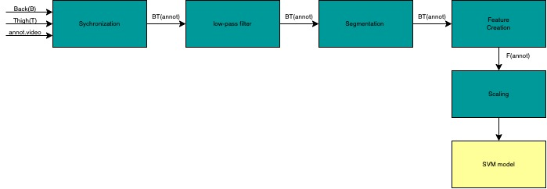

**Figure 1.** This figure shows the five steps in preprocessing performed on the data used in this project.

## Dataset

The dataset used in this paper is a publicly available HAR dataset called HARTH. For data collection, two tri-axial Axivity AX3 accelerometers were utilized (Axivity Ltd., Newcastle, UK) Axivity. Available online: **[https://axivity.com/](https://axivity.com/" \t "_blank)** (accessed on 19 April 2022). The AX3 sensor is a compact (23 x32.5x7.6 mm) dimension device that also weighs (11 g). The device can be customized using the resolution and measurement range and has a sampling rate range of 12.5-3200Hz. The accelerometer transmits data locally to the device using a 512Mb memory card and can be retrieved using a Micro-B USB connector. The AX3 device also has an ambient light sensor and a temperature sensor embedded in the device. Two sensors were used during the experiment for the following reasons. First, after conducting research where up to six sensors were examined and there was no found substantial improvement in performance over two sensors (Cleland et al, 2013, p9183-9200). Similar results were observed in the work of Awais et al. (Awais et al, 2019, p197-207). As a result, two sensors provide better accuracy, increased participant comfort, and lower costs of operation. Second, prior research employing two AX3 with comparable sensor placements yielded good results (Stewart et al,2018, p2595-2602; Narayanan et al, 2020, p252-258). The acronym "HARTH" stands for "Human Activity Recognition Trondheim." It's called after the location where it was first documented.

One sensor was connected to the front thigh of each participant (about 10 cm above the top kneecap) while the second one was attached to the lower back which is located at the 3rd lumbar vertebra, as shown in Figure 1. The AX3 device is vertically positioned on the skin, directing the USB connector to point downward. As a result, the lower back sensor's x-axis faces downward, the y-axis to the left, and the z-axis forward, as viewed from the participant's standpoint when standing up straight. The thigh sensor points backward as it indicates the position of the z-axis and to the right for the y-axis.

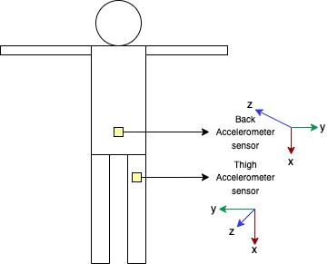

**Figure 2** This figure shows the placement of the two sensors located on the back and thigh of the participant. The sensor on the lower back is placed on the 3rd lumbar vertebra and the sensor on the thigh is placed 10cm above the kneecap

A video camera (GoPro Hero3+) was attached to each participant's chest and aimed downwards to record leg motions, which were afterward used for annotation. The information was gathered from a total of twenty-two healthy people (eight of whom were female).

The dataset for the project was recorded over two sessions. The first session had 15 (six female) participants who were instructed to go about their daily lives as normally as possible for 1.5–2 hours. The following activities were performed: standing, walking, lying, running, and sitting for 2-3 mins. The sampling rate used for capturing the data was 100Hz and was later downsized to 50Hz. For signal synchronization, the participants were advised to perform a heel drop as the recording commenced. The participants also engaged in other activities which were characterized as follows: stairs (ascending), stairs(descending), shuffling, cycling, and transport. Summing up the labels to twelve.

The second session was conducted in a free-living environment. The goal was to gather the remaining data on running, cycling, and walking. The participants were also asked to engage in other activities like sitting, lying, and walking on the stairs. Each of these activities was annotated. Using the ANVIL annotation tool, human experts were able to independently annotate the data. Which resulted in a Fleiss’ Kappa score of 0.96. Each annotation was done by an expert for each participant.

## Feature Extraction and Feature Selection

After conducting preprocessing on the data set, the time- and frequency domains were used to gather data from each frame for the machine learning model. In other to determine the feature extraction, eight signals were considered, with the six axes (three per sensor), and the vector magnitude for each sensor √x + y + z. The human orientation and movement features extracted from the raw accelerometer signal were computed in other to determine the gravity and movement component. The fourth-order 1Hz low-pass Butterworth filter was effective in estimating the gravity component of the accelerometer signal. The movement component was then obtained from the subtraction of the resultant gravity component from the raw signal. To get the orientation information for the gravity components, the mean, median, standard deviation, coefficient of variation, and the 25th and 75th percentiles were computed. While the kurtosis, the total signal power, signal energy, the spectral centroid, the standard deviation of frequency-domain magnitudes, the mean of frequency-domain magnitudes, the dominant frequency, the dominant frequency magnitude. According to Narayanan et al, cross-sensory features have a solid impact on the end performance of machine learning (Narayanan et al, 2020, p252-258).

For each window, a total of 161 features were extracted. The goal of the SVM is to learn and predict the dataset's nine labels.

## Classification

In this project, I considered the Support Vector Machine (SVM) classifier approach as a supervised machine learning model for Human Activity Recognition (HAR).

Vapnik was the first to propose SVM, and it is now widely used in nonlinear regression and pattern classification. The fundamental concept is to use a classification hyperplane as a decision surface and optimize the separation edge between positive and negative situations.

SVM is a mathematically based approximate implementation of structural risk reduction. This theory applies because the learning machine's error rate (generalization error) is based on test data. It is also constrained by the total of the training error rate and a VC dimension (Vapnik–Chervonenkis dimension) term. SVM is zero for the previous term inseparable mode and minimizes the second term. As a result, while not exploiting the difficult domain problem, the SVM has great generalization performance on the pattern classification problem, which is a distinguishing feature of the SVM. The SVM learning algorithm is built around the concept of the inner product nucleus between the support vector x(i) and the vector x retrieved from the input space. A limited piece of the method is taken from the training data to create the SVM.

### Binary Classification SVM

The Binary-Support Vector Machine (SVM) model is a standard two-class SVM model with the following specific form.

1. Identify a training set

𝑇={ (𝑥1,𝑦1),…,(𝑥𝑙,𝑦𝑙) } ∈ (𝑋 x 𝑌)𝑙

Where 𝑥i ∈ X = Rn, yi ∈ Y = { 1, -1} (i = 1, 2,…., l), and 𝑥i is the eigenvector

1. Using the suitable kernel function, and the suitable C parameter; determine a solution to the optimization problem.

min𝛼 $\frac{1}{2}$ $\sum_{i=1}^{j}{} \sum_{j=1}^{l}{}$ 𝑦𝑖 𝑦𝑗 𝛼𝑖 𝛼𝑗 𝐾 (𝑥𝑖,𝑥𝑗)− 𝛼𝑗

𝑦𝑗 𝛼𝑖 = 0, 0 < 𝛼𝑖 < C , i = 1,…, l

The optimal solution: 𝛼∗ = (𝛼1∗, … , 𝛼𝑙∗ )𝑇

1. Determine the threshold

b\*= 𝑦𝑗 - 𝑦𝑗 𝛼𝑖\*𝐾 (𝑥𝑖 - 𝑥𝑗)

1. Decision function

f(𝑥)=sgn ( 𝛼𝑖\* 𝑦i 𝐾 (𝑥, 𝑥i)+ b\*)

### Multi-Class SVM

The SVM method was created with binary classification issues in mind. When dealing with a variety of problems, we must create a suitable multi-classifier. There are currently two basic methods for building SVM multi-classifiers. The direct technique, which correctly adjusts the objective function and integrates the parameters of many classification surfaces into one optimization problem, is one example. The optimization problem is used to accomplish multi-class classification. This strategy appears straightforward, but it has high computational complexity and is difficult to execute, therefore it is only useful for small-scale problems. The alternative way is an indirect strategy that involves integrating numerous binary classifiers, such as one-versus-rest and one-versus-one.

1. One-versus-rest method

This process involves the training of each class’s sample after categorizing with an initial set, while the remaining samples are assigned to a different category this results in a K class of samples used to create a K SVM. The unknown samples are classified into the highest classification function value.

1. One-versus-one method

The method is to create an SVM in between two sorts of samples, hence with k samples, you'll have to create k (k – 1)/2 SVMs. While categorizing an unknown sample, the class with the most votes is the unidentified sample's category.

### Advantages associated with SVM

Some of the benefits associated with SVM include: It is the best option when working with a distinct dividing margin. Another benefit is that it works well in three-dimensional areas and when the number of dimensions exceeds the number of samples, it can also be very functional. Finally, it is memory-efficient because it employs a subset of training points (called support vectors) in the decision function.

## Implementing SVM in Python

The implementation of SVM in python can be described as straightforward with the use of the Scikit Learns SVM package.

First, the data is imported using the import from the pandas’ library. Followed by a reading of the file in CSV format while assigning a variable to the file.

Second, the data is split into two sets which include the training set and test samples. Sklearn model is used in this case to import the split for the training set.

Third, the predictors are then classified into train and tests with variables assigned to each predictor.

Fourth, at this stage, the Support Vector Machine is initialized and the classifier is also decided. In this study, I used the software programming language python to implement a multi-class SVM classifier with a one-versus-rest method and choose a radial basis function (RBF) kernel because of the nonlinear relationship of the dataset. The parameters C and gamma were used to get the best classifier for the datasets. The weight of the error penalty is C, while the width of the RBF kernel is gamma. The set of (C, gamma) that optimizes the cross-validation rate in the analysis is used to pick the right SVM classifier, which improves the accuracy of the output.

Finally, the prediction for the class of the test set is initialized and attachment to the prediction for the test set is implemented. A confusion matrix is then used to calculate the accuracy of the predictions.

# **Chapter Four**

The analysis of the experiment was conducted in two parts. First, I used hyperparameter optimization to determine the suitable hyperparameter for the machine learning model and also a systemic performance analysis of the HARTH dataset. Simultaneously I compared the identification of the accuracy of the physical activities with the prior research conducted using the HARTH dataset.

## Performance Analysis

I employed a series of evaluations with the confusion matrix as indicated below to examine the reliability of classification of the support vector machine performance. The accuracy of the SVM classification technique I utilized is determined by the label information of the testing set output, which belongs to the supervised learning model. In the chart below the horizontal indicates the predicted label information, whereas the vertical represents the actual label information. There are four types of classification situations using the confusion matrix. These include the True Positive (TP), in this case, the positive sample is classed as a positive class. The second classification is the False Positive (FP), here the negative sample is classed as a positive class. The third classification is the False Negative (FN), where the positive sample is classed as negative. Finally, the True Negative (TN) classification is used to indicate a negative sample classed as negative.

Therefore, based on the following four assessment metrics to indicate classification performance, the accuracy, precision, recall, and F-measure were determined.

When evaluating the benefits and drawbacks of the SVM classification method, accuracy is the most commonly used metric.

Accuracy = $\frac{Npre}{Ntotal}$

Where Npre = Number of samples predicted = TP + TN

Ntotal = Total number of samples = TP + TN + FP + FN

Accuracy = $\frac{TP+TN }{TP+TN+FP+FN}$ = $\frac{TP+TN}{P+N}$

Where P = TP + FN= Number of positive samples

N = TN + FP= Number of negative samples.

Another important metric in the assessment method is precision. It measures the model's capacity to distinguish negative samples, and the higher the Precision, the better the model's ability to distinguish negative samples. Precision is represented as follows:

Precision = $\frac{TP}{TP+FP}$

The ability of the classification model to recognize the positive samples is defined as Recall. It is defined as follows:

Recall = $\frac{TP}{TP+FN}$ = $\frac{TP}{P}$

F-Measure can be defined as a way to integrate Precision and Recall into a single metric and can be determined as follows:

F – Measure = $\frac{2TP}{2TP+FN+FP}$ = $\frac{2 X Precision x Recall}{Precision+Recall}$

The higher the F-Measure is the better classification.

## Experimental Result

The result of the HARTH dataset is presented in the following aspects: (1) the comparison of the recognition rate by utilizing the parameters C which is a regularization parameter and gamma (γ). The following range of C was evaluated [1,10,100,1000] while the gamma was set to [scale, 0.001,0.0001]. The resulting metrics are discussed below.

****

**Figure 3** This figure shows the count and labels of the HARTH dataset. The label indicates the activities carried out and the count indicates the number of activities present in each set

The figure above shows the distribution of each activity and the number of times each label appears in the dataset. From the figure above it is evident that label 7 has the highest number of counts followed by label 6. The table below accurately describes each label in terms of their activity.

|  |  |
| --- | --- |
| Labels | Activities |
| 1 | Walking |
| 3 | Running |
| 4 | Stairs(ascending) |
| 5 | Stairs(descending) |
| 6 | Standing |
| 7 | Sitting |
| 8 | Lying |
| 13 | Cycling(sit) |
| 14 | Cycling(stand) |

**Table 4** This table shows the interpretation of each label number in direct correlation with the activities.

The table above indicates the label used in the Harth dataset and its direct correlation with activities conducted in the free-living environment.

## Hyperparameter Analysis.

### For C = 1 and Gamma = scale.

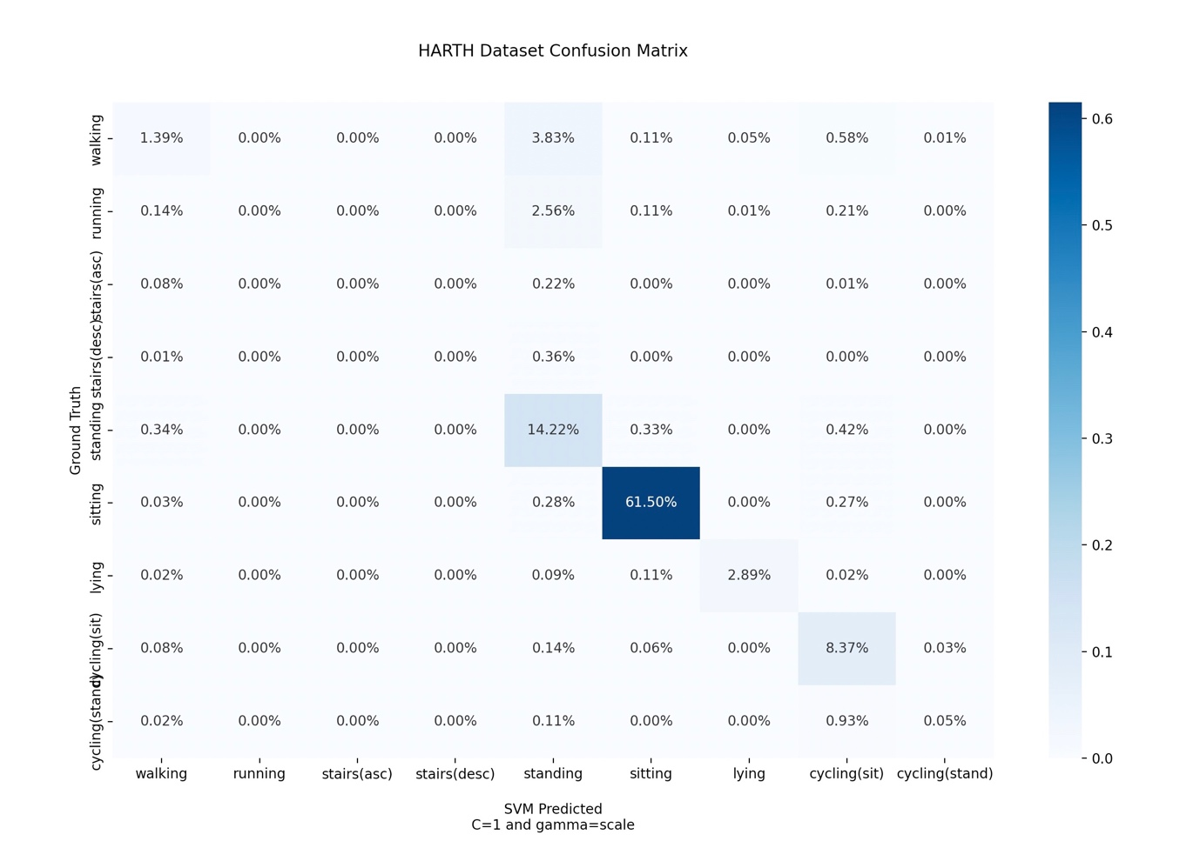

**Figure 4** This figure shows the Confusion matrix of the data with C=1 and gamma=scale

In the Confusion matrix in ***Figure 4***, Siting has the highest recognition rate of 61.50% followed closely by standing which has a recognition rate of 14.22%. The lowest activity recognized include stand(ascending), stand(descending), and running.

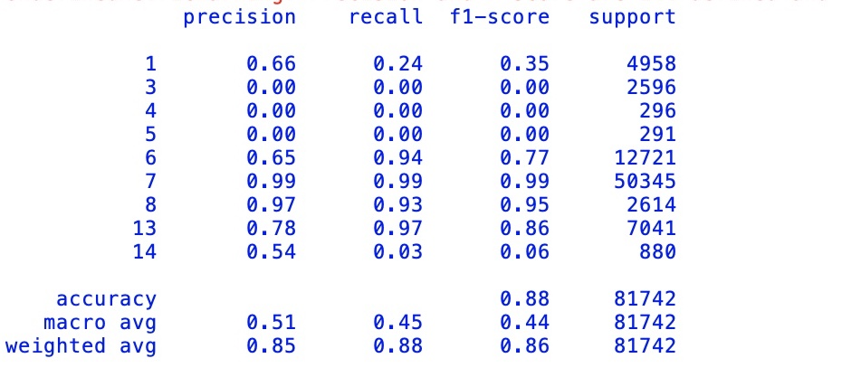

**Figure 5** The figure above shows the Classification report for the SVM RBF model, C=1

In the Classification report above, the activity Sitting has the highest Precision (99%), Recall (99%), and f1-score rate (99%). Lying also has a high precision (97%), Recall (93%), and f1-score rate (95%). The activities that have the lowest metric rate include Walking, which has a Precision (66%), Recall (24%) and f1-score (35%), and Cycling(standing) which has a precision (54%), Recall (3%), and f1-score (6%).

The accuracy of the test model is given as 88.42%.

### For C = 10 and Gamma = scale.

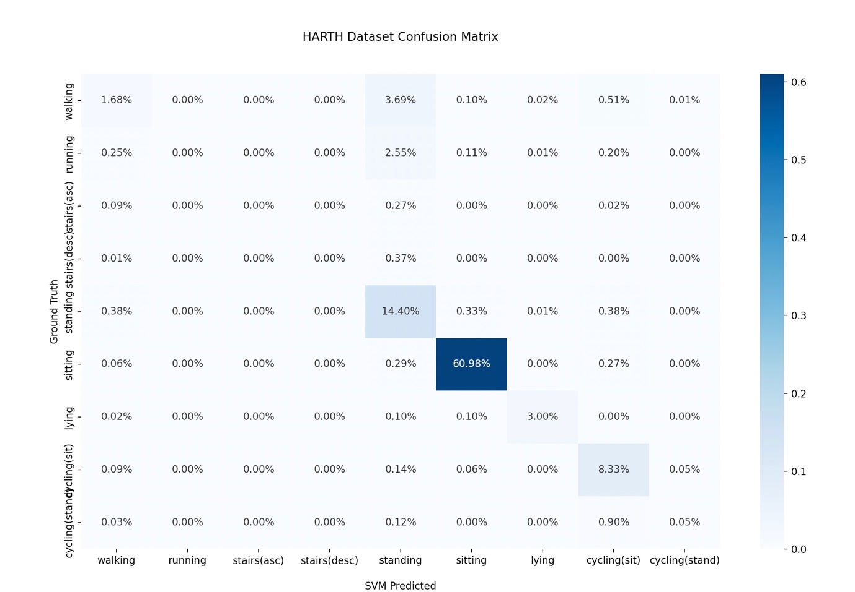

**Figure 6** This figure shows the Confusion matrix of the data with C=10 and gamma=scale

In the Confusion matrix in ***Figure 6***, Siting has the highest recognition rate of 60.98% followed closely by standing which has a recognition rate of 14.40%. The lowest activity recognized include stand(ascending), stand(descending), and running.

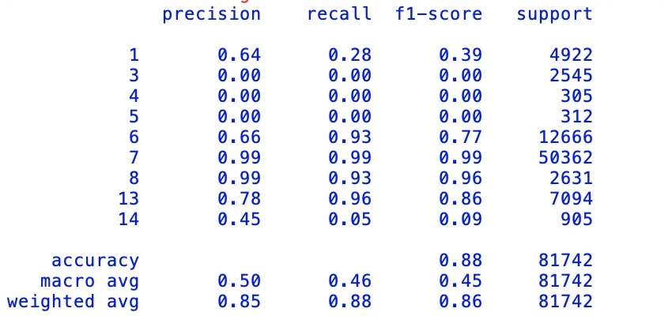

**Figure 7** The figure above shows the Classification report for the SVM RBF model, C=10

In the Classification report above, the activity **Sitting** has the highest Precision (99%), Recall (99%), and f1-score rate (99%). Lying also has a high precision (99%), Recall (93%), and f1-score rate (96%). The activities that have the lowest metric rate include Walking, which has a Precision (64%), Recall (28%) and f1-score (39%), and Cycling(standing) which has a precision (45%), Recall (5%), and f1-score (9%).

The accuracy of the test model is given as 88.45%.

### For C = 100 and Gamma = scale.

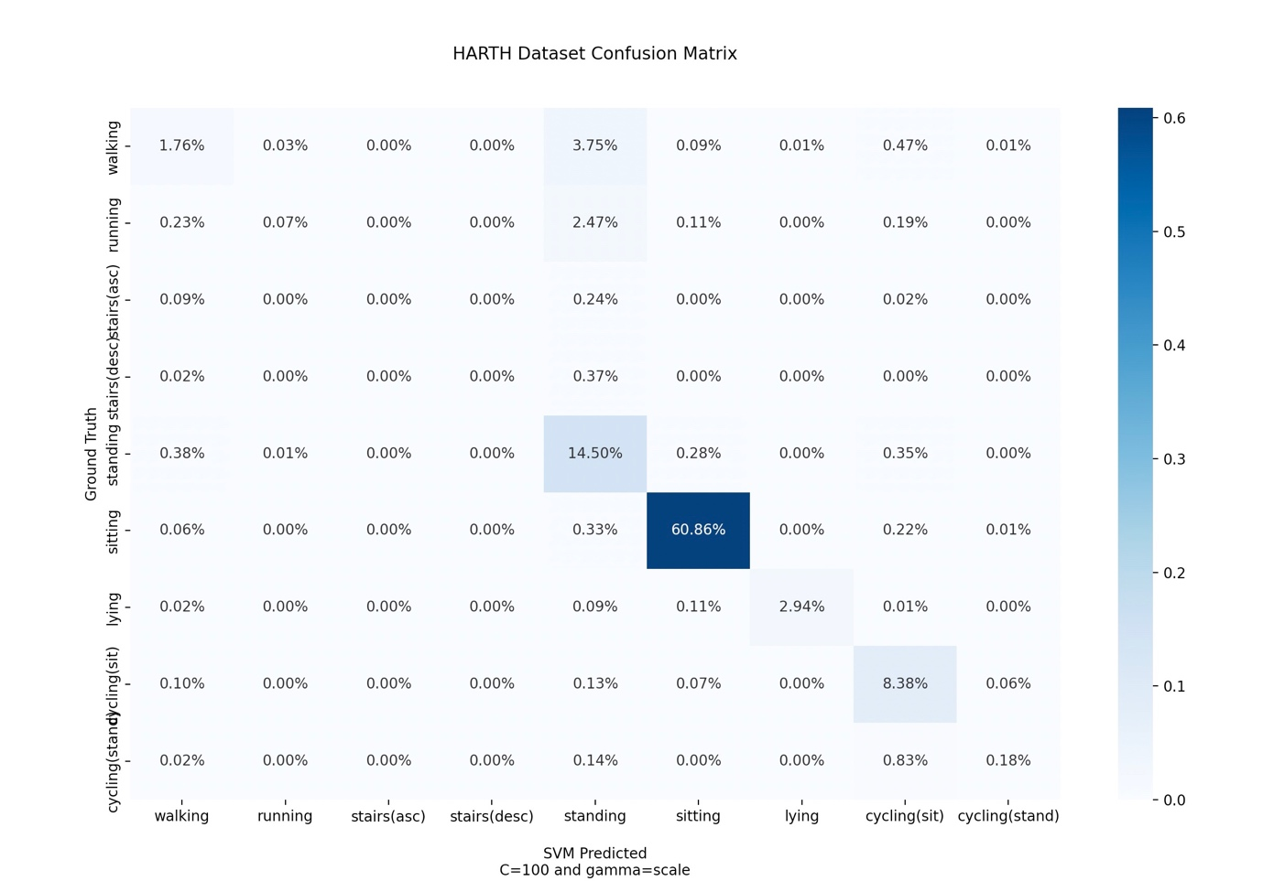

**Figure 8** This figure shows the Confusion matrix of the data with C=100 and gamma=scale

In the Confusion matrix in ***Figure 8***, Siting has the highest recognition rate of 60.86% followed closely by standing which has a recognition rate of 14.50%. The lowest activity recognized include stand(ascending), and stand(descending).

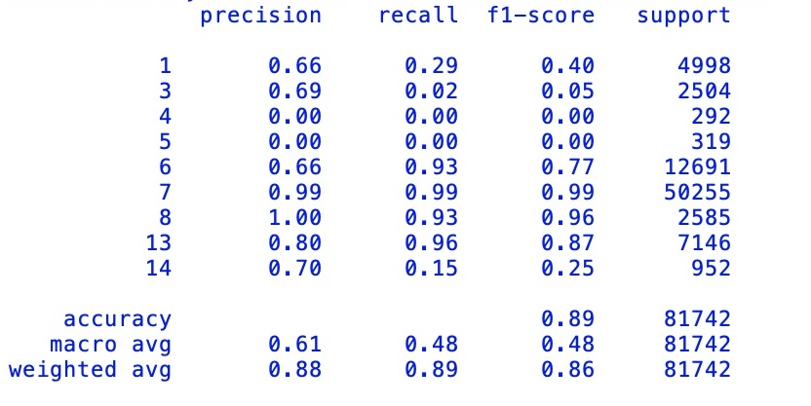

**Figure 9** The figure above shows the Classification report for the SVM RBF model, C=100.

In the Classification report above, the activity **Sitting** has the highest Precision (99%), Recall (99%), and f1-score rate (99%). Lying also has a high precision (100%), Recall (93%), and f1-score rate (96%). The activities that have the lowest metric rate include Walking, which has a Precision (66%), Recall (29%) and f1-score (40%), and running which has a precision (69%), Recall (2%), and f1-score (5%).

The accuracy of the test model is given as 89%.

### For C = 1000 and Gamma = scale

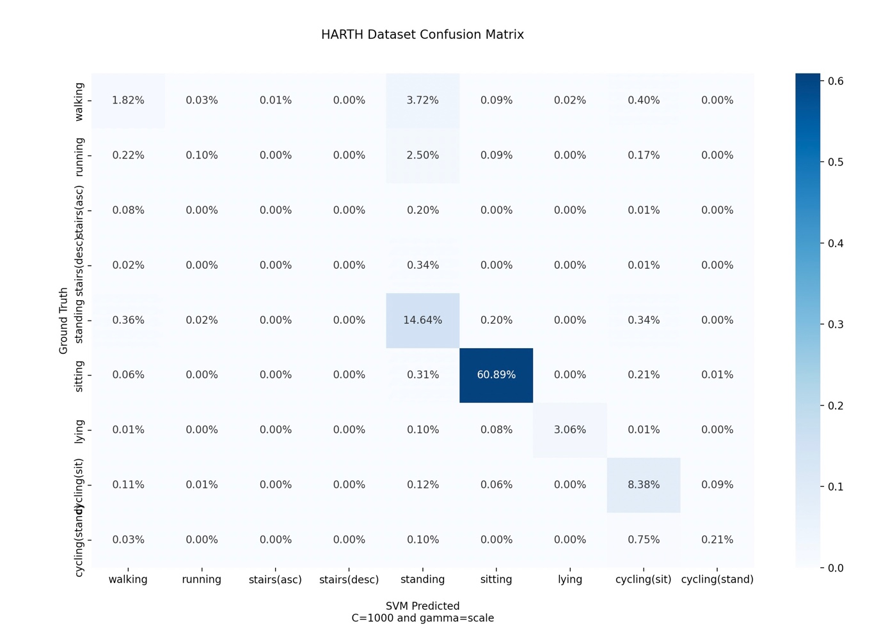

**Figure 10** This figure shows the Confusion matrix of the data with C=1000 and gamma=scale

In the Confusion matrix in ***Figure 10***, Siting has the highest recognition rate of 60.89% followed closely by standing which has a recognition rate of 14.64%. The lowest activity recognized include stand(ascending), and stand(descending).

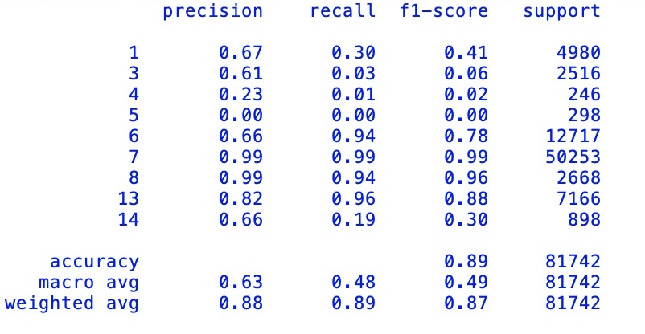

**Figure 11** The figure above shows the Classification report for the SVM RBF model, C=1000.

In the Classification report above, the activity **Sitting** has the highest Precision (99%), Recall (99%), and f1-score rate (99%). Lying also has a high precision (99%), Recall (94%), and f1-score rate (96%). The activities that have the lowest metric rate include Running, which has a Precision (61%), Recall (3%) and f1-score (6%), and Stairs(ascending) which has a precision (23%), Recall (1%), and f1-score (2%).

The accuracy of the test model is given as 89%.

### For C = 1 and Gamma = 0.001

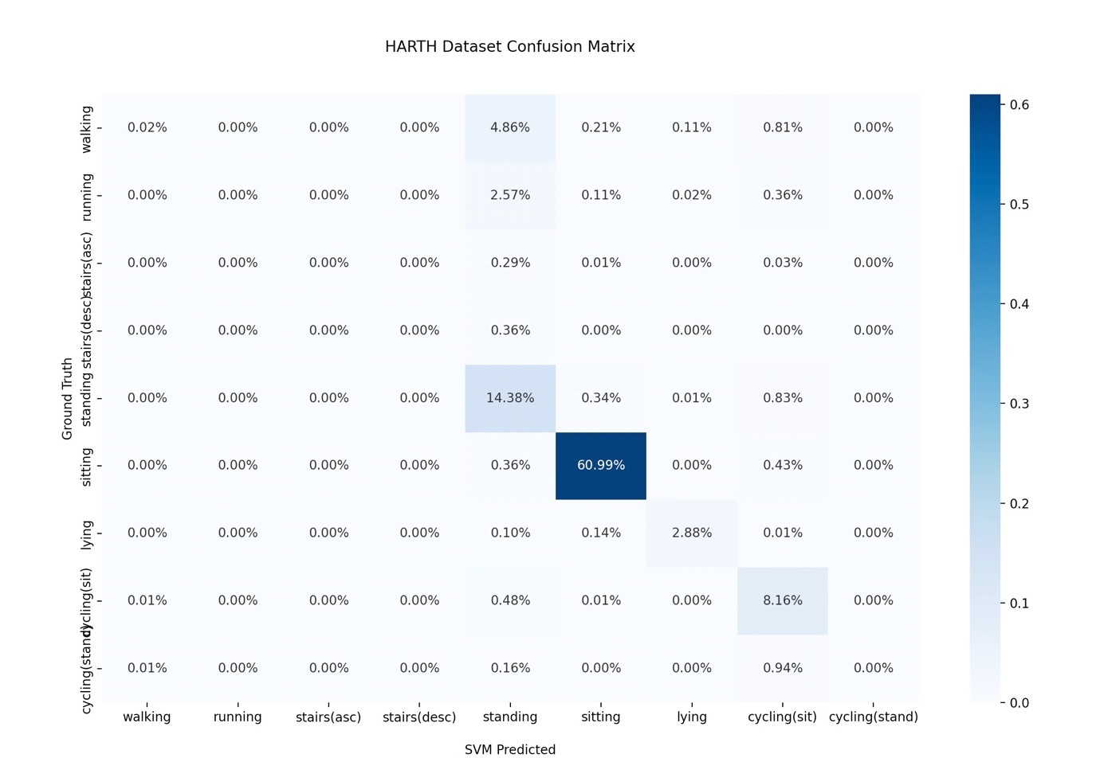

**Figure 12** This figure shows the Confusion matrix of the data with C=1 and gamma=0.001

In the Confusion matrix in ***Figure 12***, Siting has the highest recognition rate of 60.99% followed closely by standing which has a recognition rate of 14.38%. The lowest activity recognized include stand(ascending), stand(descending), and running.

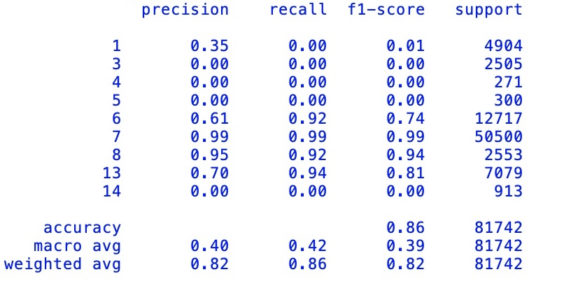

**Figure 13** The figure above shows the Classification report for the SVM RBF model, C=1, gamma=0.001

In the Classification report in ***Figure 13***, the activity **Sitting** has the highest Precision (99%), Recall (99%), and f1-score rate (99%). Lying also has a high precision (95%), Recall (92%), and f1-score rate (94%). The activities that have the lowest metric rate include Walking, Cycling(standing), running, stairs (ascending), and stairs (descending) which have a Precision (0%), Recall (0%), and f1-score (0%).

The accuracy of the test model is given as 86.42%.

### For C = 10 and Gamma = 0.001

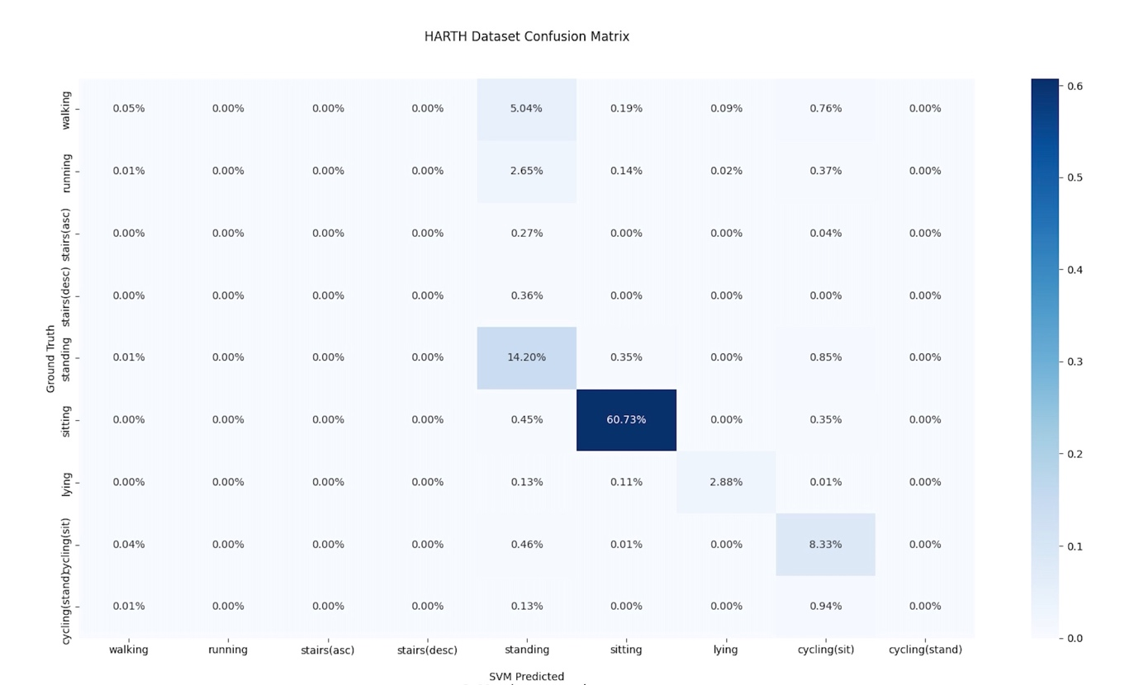

**Figure 14** This figure shows the Confusion matrix of the data with C=10 and gamma=0.001

In the Confusion matrix in ***Figure 14***, Siting has the highest recognition rate of 60.73% followed closely by standing which has a recognition rate of 14.20%. The lowest activity recognized include stand(ascending), stand(descending), running, and cycling(stand).

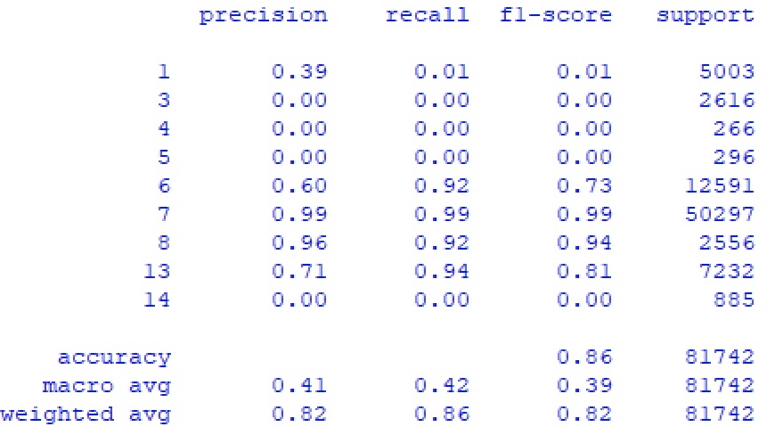

**Figure 15** The figure above shows the Classification report for the SVM RBF model, C=10, gamma=0.001.

In the Classification report in ***Figure 15***, the activity Sitting has the highest Precision (99%), Recall (99%), and f1-score rate (99%). Lying also has a high precision (96%), Recall (92%), and f1-score rate (94%). The activities that have the lowest metric rate include Walking, Cycling(standing), running, stairs (ascending), and stairs (descending) which have a Precision (0%), Recall (0%), and f1-score (0%).

The accuracy of the test model is given as 86.19%.

### For C = 100 and Gamma = 0.001

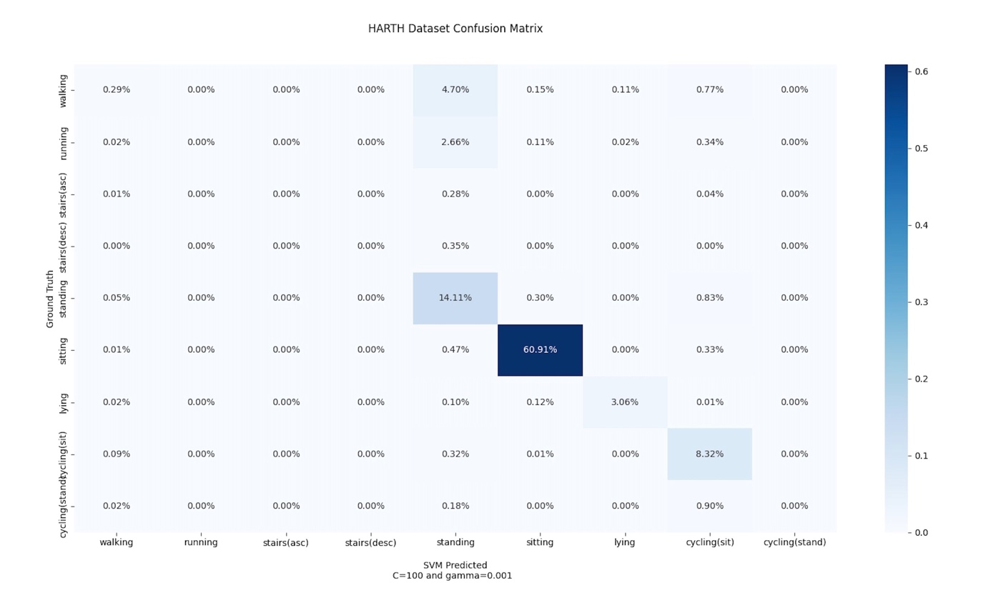

**Figure 16** This figure shows the Confusion matrix of the data with C=100 and gamma=0.001

In the Confusion matrix in ***Figure 16***, Siting has the highest recognition rate of 60.91% followed closely by standing which has a recognition rate of 14.11%. The lowest activity recognized include stand(ascending), stand(descending), running, and cycling(stand).

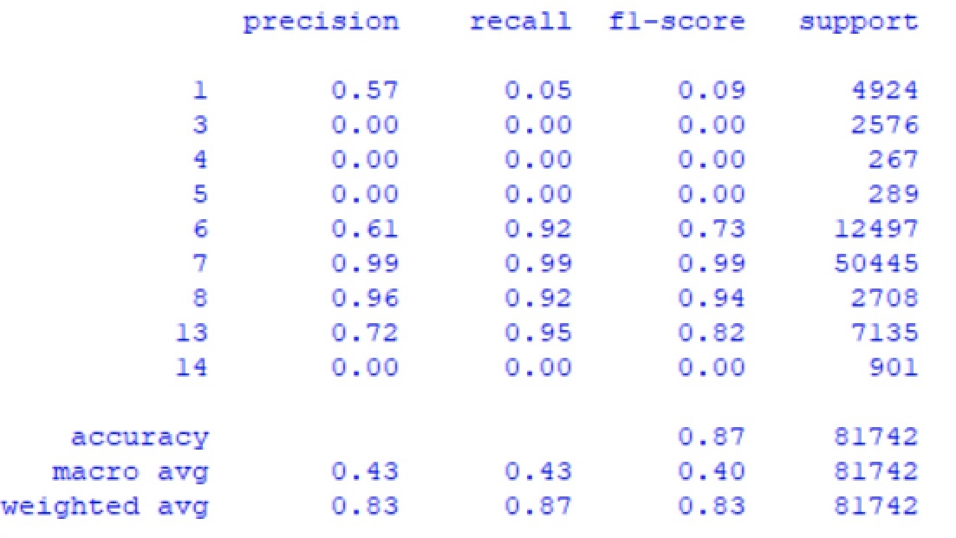

**Figure 17** The figure above shows the Classification report for the SVM RBF model, C=100, gamma=0.001.

In the Classification report in ***Figure 17***, the activity **Sitting** has the highest Precision (99%), Recall (99%), and f1-score rate (99%). Lying also has a high precision (96%), Recall (92%), and f1-score rate (94%). The activities that have the lowest metric rate include Walking, Cycling(standing), running, stairs (ascending), and stairs (descending) which have a Precision (0%), Recall (0%), and f1-score (0%).

The accuracy of the test model is given as 86.67%.

### For C = 1000 and Gamma = 0.001

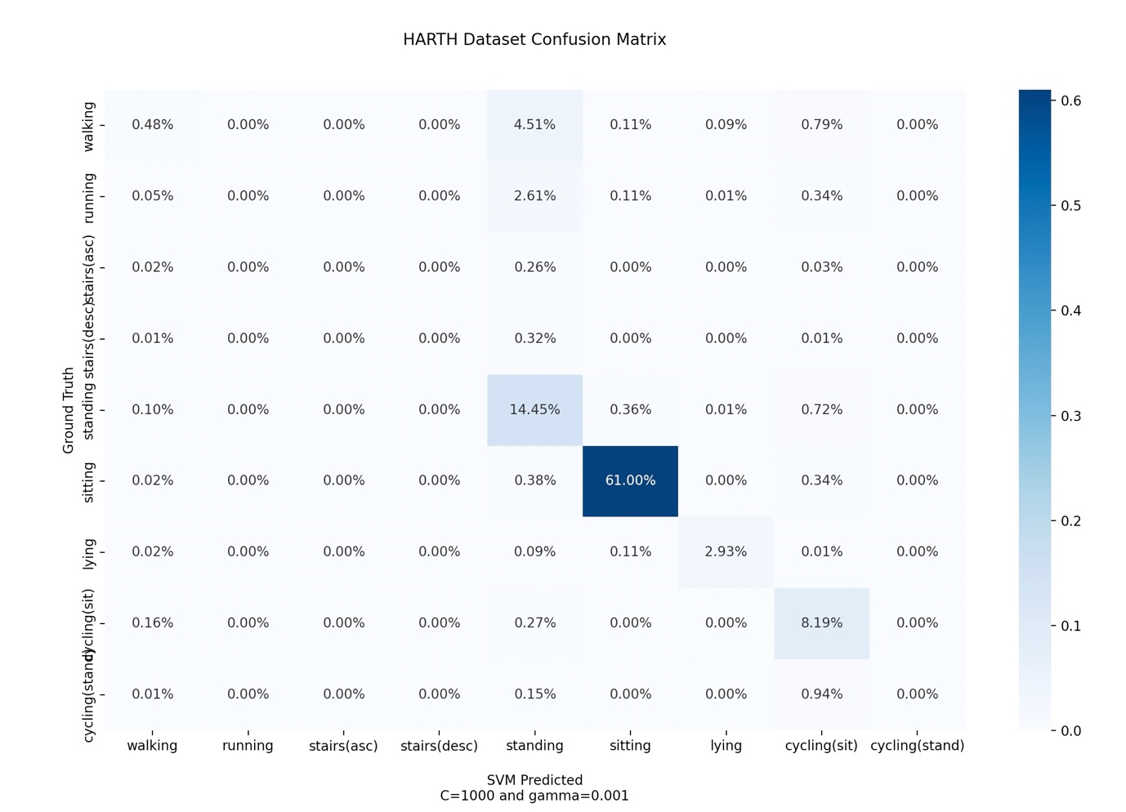

**Figure 18** This figure shows the Confusion matrix of the data with C=1000 and gamma=0.001

In the Confusion matrix in ***Figure 18,*** Siting has the highest recognition rate of 61.00% followed closely by standing which has a recognition rate of 14.45%. The lowest activity recognized include stand(ascending), stand(descending), and running.

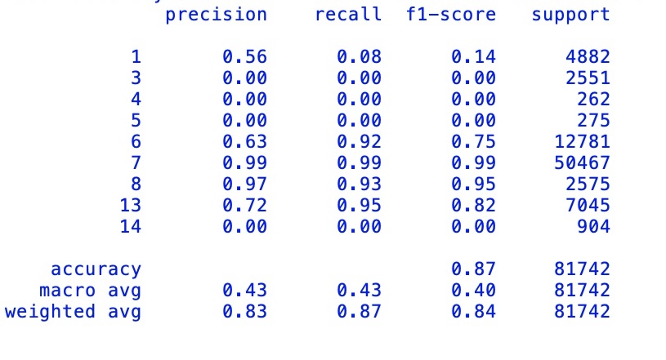

**Figure 19** The figure above shows the Classification report for the SVM RBF model, C=1000, gamma=0.001.

In the Classification report in ***Figure 19***, the activity **Sitting** has the highest Precision (99%), Recall (99%), and f1-score rate (99%). Lying also has a high precision (97%), Recall (93%), and f1-score rate (95%). The activities that have the lowest metric rate include Walking, Cycling(standing), running, stairs (ascending), and stairs (descending) which have a Precision (0%), Recall (0%), and f1-score (0%).

The accuracy of the test model is given as 87.04%.

### For C = 1 and Gamma = 0.0001

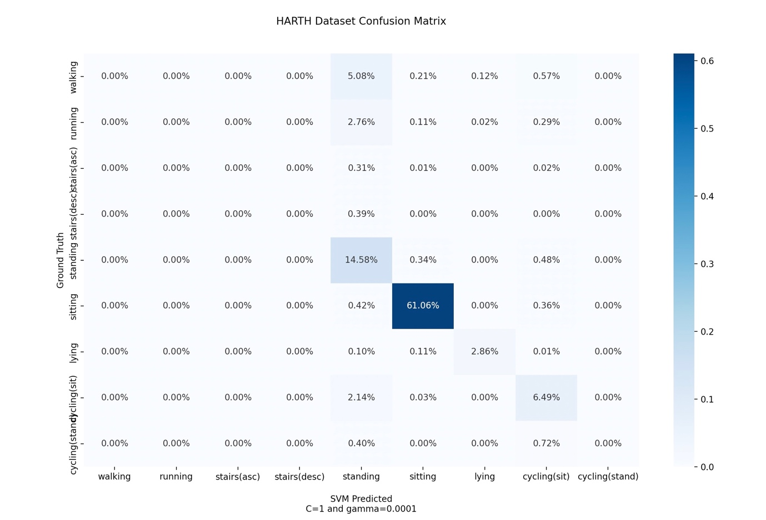

**Figure 20** This figure shows the Confusion matrix of the data with C=1 and gamma=0.0001

In the Confusion matrix in ***Figure 20,*** Siting has the highest recognition rate of 61.08% followed closely by standing which has a recognition rate of 14.58%. The lowest activity recognized include stand(ascending), stand(descending), and running.

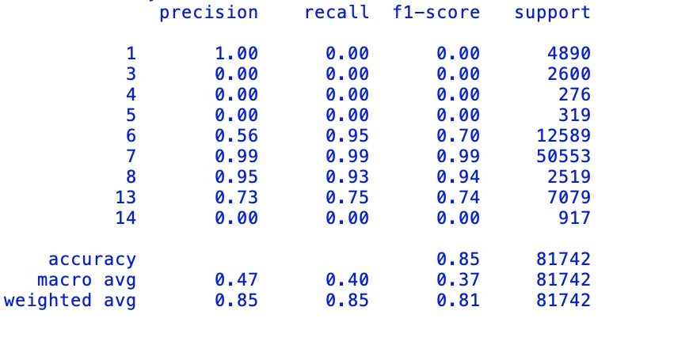

**Figure 21** The figure above shows the Classification report for the SVM RBF model, C=1, gamma=0.0001

In the Classification report in ***Figure 21***, the activity **Sitting** has the highest Precision (99%), Recall (99%), and f1-score rate (99%). Lying also has a high precision (95%), Recall (93%), and f1-score rate (94%). The activities that have the lowest metric rate include Walking, Cycling(standing), running, stairs (ascending), and stairs (descending) which have a Precision (0%), Recall (0%), and f1-score (0%).

The accuracy of the test model is given as 84.99%.

### For C = 10 and Gamma = 0.0001

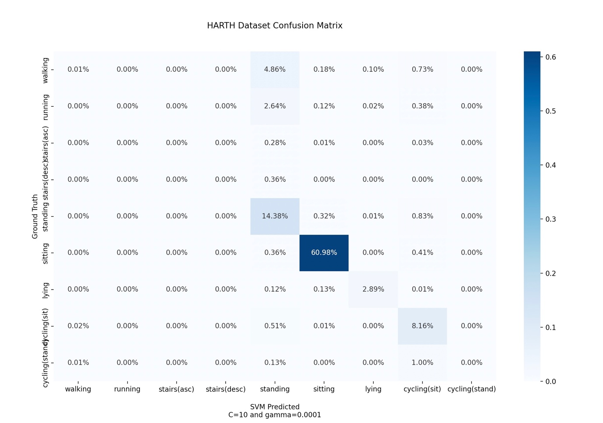

**Figure 22** This figure shows the Confusion matrix of the data with C=10 and gamma=0.0001

In the Confusion matrix in ***Figure 22,*** Siting has the highest recognition rate of 60.98% followed closely by standing which has a recognition rate of 14.38%. The lowest activity recognized include stand(ascending), stand(descending), and running.

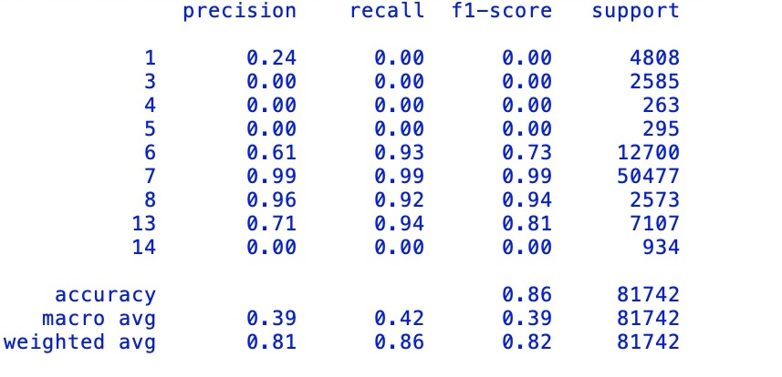

**Figure 23** The figure above shows the Classification report for the SVM RBF model, C=10, gamma=0.0001

In the Classification report in ***Figure 23***, the activity **Sitting** has the highest Precision (99%), Recall (99%), and f1-score rate (99%). Lying also has a high precision (96%), Recall (92%), and f1-score rate (94%). The activities that have the lowest metric rate include Walking, Cycling(standing), running, stairs (ascending), and stairs (descending) which have a Precision (0%), Recall (0%), and f1-score (0%).

The accuracy of the test model is given as 86.41%.

### For C = 100 and Gamma = 0.0001

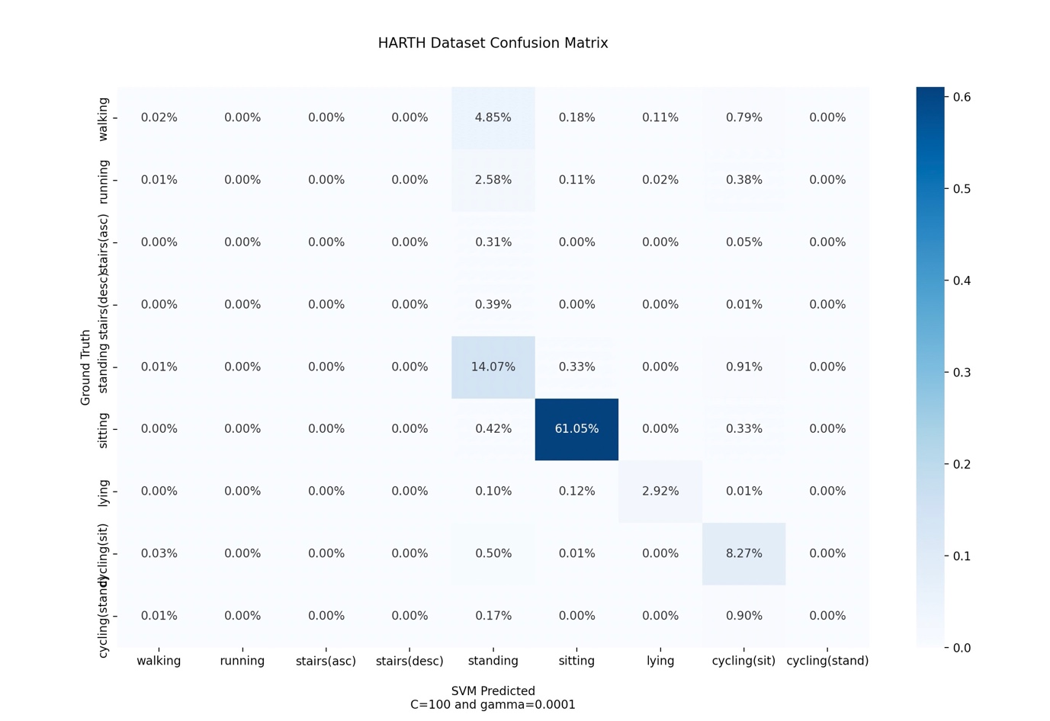

**Figure 24** This figure shows the Confusion matrix of the data with C=100 and gamma=0.0001

In the Confusion matrix in ***Figure 24,*** Siting has the highest recognition rate of 61.05% followed closely by standing which has a recognition rate of 14.07%. The lowest activity recognized include stand(ascending), stand(descending), and running.

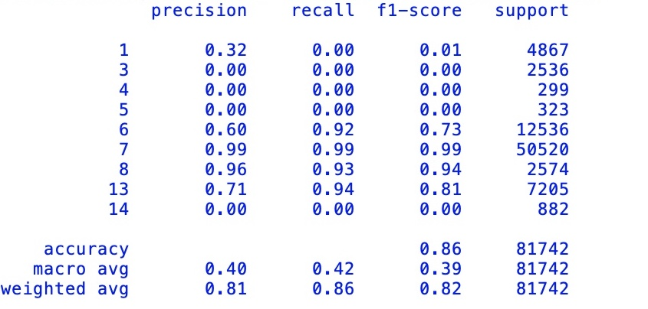

**Figure 25** The figure above shows the Classification report for the SVM RBF model, C=100, gamma=0.0001

In the Classification report in ***Figure 25***, the activity **Sitting** has the highest Precision (99%), Recall (99%), and f1-score rate (99%). Lying also has a high precision (96%), Recall (93%), and f1-score rate (94%). The activities that have the lowest metric rate include Walking, Cycling(standing), running, stairs (ascending), and stairs (descending) which have a Precision (0%), Recall (0%), and f1-score (0%).

The accuracy of the test model is given as 86.35%.

### For C = 1000 and Gamma = 0.0001

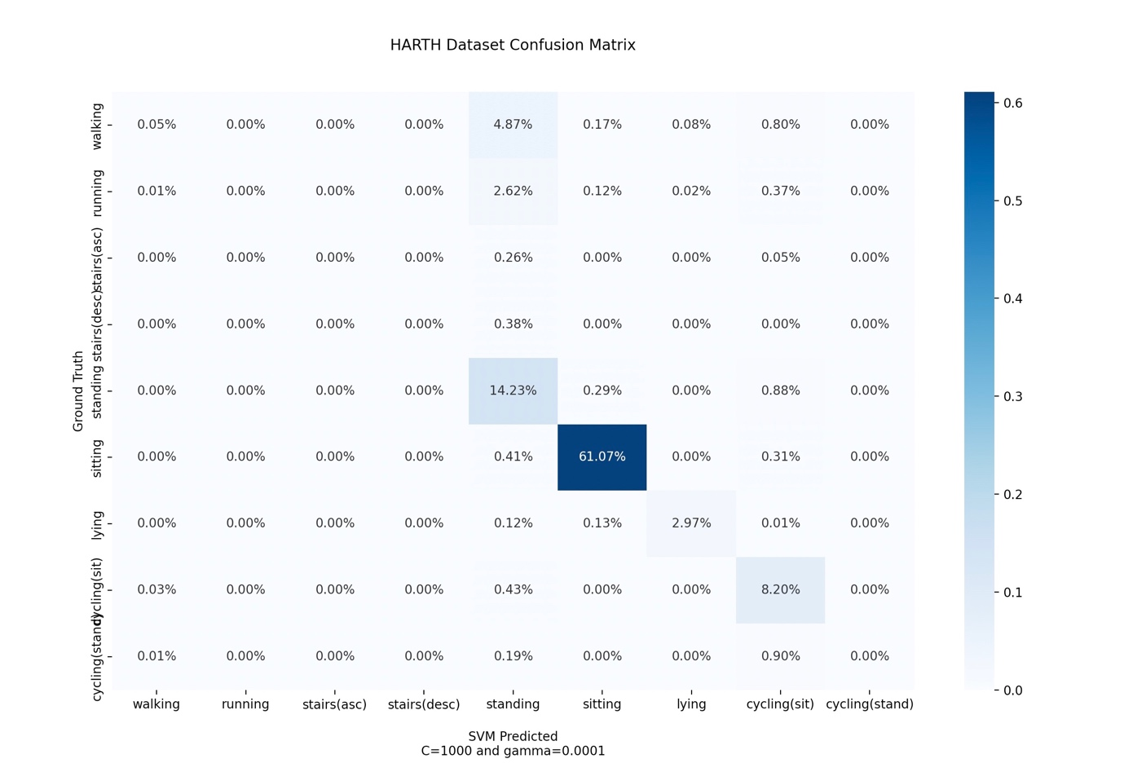

**Figure 26** This figure shows the Confusion matrix of the data with C=1000 and gamma=0.0001

In the Confusion matrix in ***Figure 26,*** Siting has the highest recognition rate of 61.07% followed closely by standing which has a recognition rate of 14.27%. The lowest activity recognized include stand(ascending), stand(descending), and running.

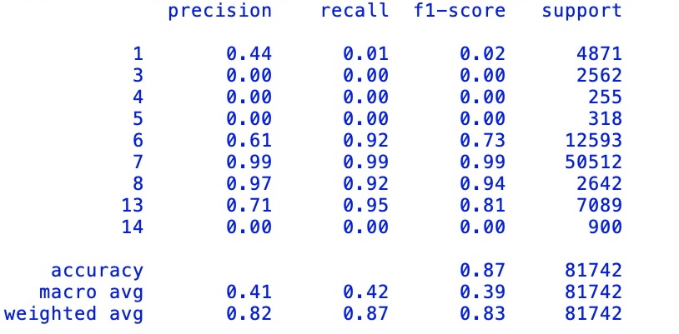

**Figure 27** The figure above shows the Classification report for the SVM RBF model, C=1000, gamma=0.0001

In the Classification report in ***Figure 27***, the activity **Sitting** has the highest Precision (99%), Recall (99%), and f1-score rate (99%). Lying also has a high precision (97%), Recall (92%), and f1-score rate (94%). The activities that have the lowest metric rate include Walking, Cycling(standing), running, stairs (ascending), and stairs (descending) which have a Precision (0%), Recall (0%), and f1-score (0%).

The accuracy of the test model is given as 86.53%.

## Performance summary

|  |  |  |  |  |
| --- | --- | --- | --- | --- |
| RBF Model | C =1 | C = 10 | C = 100 | C = 1000 |
| γ = scale | 88.42% | 88.45% | **88.79%** | 89.14% |
| γ = 0.001 | 86.42% | 86.19% | 86.67% | 87.04% |
| γ = 0.0001 | 84.99% | 86.41% | 86.35% | 86.53% |

**Table 5** The accuracy achieved for each kernel C, γ, and degree hyperparameters. The best result is highlighted in bold.

**Figure 28** . The figure above shows the accuracy distribution of the hyperparameter C and gamma.

|  |  |  |  |  |
| --- | --- | --- | --- | --- |
| RBF Model | C =1 | C = 10 | C = 100 | C = 1000 |
| γ = scale | 61.50% | 60.98% | 60.86% | 60.89% |
| γ = 0.001 | 60.99% | 60.73% | 60.91% | 61.00% |
| γ = 0.0001 | 61.06% | 60.98% | 61.05% | 61.07% |

**Table 6** This Table shows the recognition rate for sitting with various Hyperparameters.

**Figure 29** This figure shows the distribution of Recognition Rate of Sitting

## Discussion

For the Confusion matrix table, the ground truth is represented by the rows, while the SVM model predictions are represented by the columns. The Normalization of the matrices was done in other to get an approximate value of one for the sum of the values in each of the rows. The percentage of the correctly identified figure is shown in the diagonal. The activity Siting has the highest prediction percentage at 61.5% when gamma is set to scale and C is set to 1. The mean value for the recognition rate is given as 60.87% This is because, from the data set described in figure 3, sitting has the highest number of representations in the dataset. Thereby making it more prominent in the overall performance analysis. Standing, Cycling(sit), and walking have an equally high percentage. Three activities which are Stairs (asc), Stairs (DSC), and Cycling(stand) however stand out due to their low performance in each model iteration. The first two are usually confused with walking while Cycling(stand) is confused with Cycling (sit).

The mean score for gamma at scale is given as 88.7%, while that of gamma at 0.001 is given as 86.58% and the gamma at 0.0001 is given as 86.07%.

Comparing the results from the gamma values it is evident that setting gamma to scale yielded the highest accuracy.

Even though the results obtained may not appear to be as good as those found in the other of the literature, I believe they are encouraging in light of the challenge at hand. The data utilized differ significantly from other datasets currently available in the area. I feel that the outcomes may be much improved if other types of models, such as Random Forest, were utilized in this sector. Additionally, deep learning algorithms such as CNN, have demonstrated outstanding success in this domain.

## Comparison with Previous work

Aleksej et al developed a publicly available dataset for Human activity recognition and trained the dataset using the support vector machine as one of the machine learning models (Aleksej et al., 2020). Twelve activities were initially considered then later merged into nine activities. The activities include walking, running, stairs(asc), stairs(desc), standing, sitting, lying, cycling(sit), and cycling(stand). The support vector machine had the following scores given the defined metrics: F1-score – 0.81, recall- 0.85, and precision- 0.79.

In contrast, this project uses a support vector machine on the same dataset to identify the same activities given a performance analysis of each modified hyperparameter. The Hyperparameter with the best result is the regularization parameter has C set to 100 as the accuracy of the test model is given as 88.79%.

The research carried out by Aleksej et al also considered other deep learning model approaches which were not considered in this research.

# Chapter Five

## Conclusion

For public health research based on physical activity behavior, an accelerometer-based HAR dataset must have two characteristics. First, the measurements for the acceleration must be accurate, with the sensor used to determine the data located in a fixed position, noise robustness, and properly documented or annotated activities, are required. Second, the data must be collected in a free-living environment.

In this project, I began by providing an introduction and related work on Human activity recognition using SVM. Then I talked about the various method of data collection and preparation and why I selected and investigated the HARTH dataset. I determined the various Hyperparameters used for the support vector classification for the HARTH dataset by carrying out a comparative experiment using Python as the programming language tool. The results showed C equal to 100(C=100) and gamma equal to scale (γ = scale) as the best Hyperparameter that supports the determination of physical activity recognition using the support vector machine model.

Support Vector Model (SVM) computational time is directly proportional to the available training set. In this project, I observed that with an increase in the hyperparameters there was more computation time required to complete the analysis. I also observed that the system performed poorly in terms of recognition rate for activities with fewer data counts and training sets while the accuracy improves as the number of activity training sets increases.

In the future, I want to carry out more research on examining the various extraction techniques for the dataset and also the class weight balancing while introducing a cross-validation technique in other to improve the results and the accuracy of the model. My results demonstrate that there is still an opportunity for more research to create innovative machine learning algorithms to aid in the detection of human activities in free-living environments.

# Reference

1. About HUNT-The Nord-Trøndelag Health Study-NTNU. Available online: **[https://www.ntnu.edu/hunt/about-hunt](https://www.ntnu.edu/hunt/about-hunt" \t "_blank)** (accessed on 16 April 2022).
2. Ahmadi, M.N.; Brookes, D.; Chowdhury, A.; Pavey, T.; Trost, S.G. Free-living Evaluation of Laboratory-based Activity Classifiers in Preschoolers. Med. Sci. Sport. Exerc. **2020**, 52, 1227–1234.
3. Ahmadi, M.N.; Pavey, T.G.; Trost, S.G. Machine Learning Models for Classifying Physical Activity in Free-Living Preschool Children. Sensors **2020**, 20, 4364.
4. Axivity. Available online: **[https://axivity.com/](https://axivity.com/" \t "_blank)** (accessed on 16 April 2022).
5. Baldominos Alejandro, Yago Saez, and Pedro Isasi, "Feature Set Optimization for Physical Activity Recognition Using Genetic Algorithms", Proceedings of the Companion Publication of 2015 on Genetic and Evolutionary Computation Conference, 2015.
6. Baños, O.; Damas, M.; Pomares, H.; Rojas, I.; Tóth, M.A.; Amft, O. A benchmark dataset to evaluate sensor displacement in activity recognition. In Proceedings of the 2012 ACM Conference on Ubiquitous Computing, Pittsburgh, PA, USA, 5–8 September 2012; pp. 1026–1035.
7. Bao, L.; Intille, S.S. Activity Recognition from User-Annotated Acceleration Data. In Pervasive Computing; Lecture Notes in Computer Science; Ferscha, A., Mattern, F., Eds.; Springer: Berlin, Heidelberg, 2004; pp. 1–17.
8. Carpineti, C.; Lomonaco, V.; Bedogni, L.; Felice, M.D.; Bononi, L. Custom Dual Transportation Mode Detection By Smartphone Devices Exploiting Sensor Diversity. In Proceedings of the 2018 IEEE International Conference on Pervasive Computing and Communications Workshops (PerCom Workshops), Athens, Greece, 19–23 March 2018; pp. 367–372.
9. Chen Gang and Jin Chen, "A novel wrapper method for feature selection and its applications", Neurocomputing, vol. 159, pp. 219-226, 2015.
10. Cuba Gyllensten, I.; Bonomi, A. Identifying Types of Physical Activity With a Single Accelerometer: Evaluating Laboratory-trained Algorithms in Daily Life. IEEE Trans. Biomed. Eng. **2011**, 58, 2656–2663.
11. Da Silva, Fernando Ginez and Elisabete Galeazzo, "Accelerometer-based intelligent system for human movement recognition", Advances in Sensors and Interfaces (IWASI) 2013 5th IEEE International Workshop on., 2013
12. de Almeida Mendes, M.; da Silva, I.C.M.; Ramires, V.V.; Reichert, F.F.; Martins, R.C.; Tomasi, E. Calibration of raw accelerometer data to measure physical activity: A systematic review. Gait Posture **2018**, 61, 98–110.
13. Demrozi, F.; Pravadelli, G.; Bihorac, A.; Rashidi, P. Human Activity Recognition Using Inertial, Physiological and Environmental Sensors: A Comprehensive Survey. IEEE Access **2020**, 8, 210816–210836.
14. Elhattab, A.; Uddin, N.; OBrien, E. Extraction of Bridge Fundamental Frequencies Utilizing a Smartphone MEMS Accelerometer. Sensors **2019**, 19, 3143.
15. Elhattab, A.; Uddin, N.; OBrien, E. Extraction of Bridge Fundamental Frequencies Utilizing a Smartphone MEMS Accelerometer. Sensors **2019**, 19, 3143.
16. Gao, L.; Bourke, A.K.; Nelson, J. Evaluation of accelerometer-based multi-sensor versus single-sensor activity recognition systems. Med. Eng. Phys. **2014**, 36, 779–785.
17. Garcia-Gonzalez, D.; Rivero, D.; Fernandez-Blanco, E.; Luaces, M.R. A Public Domain Dataset for Real-Life Human Activity Recognition Using Smartphone Sensors. Sensors **2020**, 20, 2200.
18. Ghasemzadeh Hassan et al., "Power-Aware Computing in Wearable Sensor Networks: An Optimal Feature Selection", Mobile Computing IEEE Transactions on, vol. 14, no. 4, pp. 800-812, 2015.
19. Gjoreski, H.; Ciliberto, M.; Morales, F.J.O.; Roggen, D.; Mekki, S.; Valentin, S. A Versatile Annotated Dataset for Multimodal Locomotion Analytics with Mobile Devices. In Proceedings of the 15th ACM Conference on Embedded Network Sensor Systems, Delft, The Netherlands, 6–8 November 2017; pp. 1–2.
20. Gupta Puneet and Tim Dallas, "Feature selection and activity recognition system using a single triaxial accelerometer", Biomedical Engineering IEEE Transactions on, vol. 61, no. 6, pp. 1780-1786, 2014.
21. Gupta, R.; Gupta, A.; Aswal, R. Time-CNN and Stacked LSTM for Posture Classification. In Proceedings of the International Conference on Computer Communication and Informatics (ICCCI), Coimbatore, India, 27–29 January 2021; pp. 1–5.
22. He Zhen-Yu and Lian-Wen Jin, "Activity recognition from acceleration data using AR model representation and SVM", Machine Learning and Cybernetics 2008 International Conference on., vol. 4, 2008.
23. He Zhenyu and Lianwen Jin, "Activity recognition from acceleration data based on discrete cosine transform and SVM", Systems Man and Cybernetics 2009. SMC 2009. IEEE International Conference on., 2009.
24. Herrera-Alcántara, O.; Barrera-Animas, A.Y.; González-Mendoza, M.; Castro-Espinoza, F. Monitoring Student Activities with Smartwatches: On the Academic Performance Enhancement. Sensors **2019**, 19, 1605.
25. Ichino, H.; Kaji, K.; Sakurada, K.; Hiroi, K.; Kawaguchi, N. HASC-PAC2016: Large scale human pedestrian activity corpus and its baseline recognition. In Proceedings of the 2016 ACM International Joint Conference on Pervasive and Ubiquitous Computing, Heidelberg, Germany, 12–16 September 2016; pp. 705–714.
26. Jepsen, R.; Egholm, C.L.; Brodersen, J.; Simonsen, E.; Grarup, J.; Cyron, A.; Ellervik, C.; Rasmussen, K. Lolland-Falster Health Study: Study protocol for a household-based prospective cohort study. Scand. J. Public Health **2020**, 48, 382–390.
27. Kaji, K.; Watanabe, H.; Ban, R.; Kawaguchi, N. HASC-IPSC: Indoor pedestrian sensing corpus with a balance of gender and age for indoor positioning and floor-plan generation researches. In Proceedings of the 2013 ACM Conference on Pervasive and Ubiquitous Computing Adjunct Publication, Zurich, Switzerland, 8–12 September 2013; pp. 605–610.
28. Kawaguchi, N.; Ogawa, N.; Iwasaki, Y.; Kaji, K.; Terada, T.; Murao, K.; Inoue, S.; Kawahara, Y.; Sumi, Y.; Nishio, N. HASC Challenge: Gathering large scale human activity corpus for the real-world activity understandings. In Proceedings of the 2nd Augmented Human International Conference, Tokyo, Japan, 13 March 2011; pp. 1–5.
29. Kawaguchi, N.; Watanabe, H.; Yang, T.; Ogawa, N.; Iwasaki, Y.; Kaji, K.; Terada, T.; Murao, K.; Hada, H.; Inoue, S.; et al. HASC2012corpus: Large Scale Human Activity Corpus and Its Application. In Proceedings of the Second International Workshop of Mobile Sensing: From Smartphones and Wearables to Big Data, Beijing, China, 16–20 April 2012; pp. 10–14.
30. Kawaguchi, N.; Yang, Y.; Yang, T.; Ogawa, N.; Iwasaki, Y.; Kaji, K.; Terada, T.; Murao, K.; Inoue, S.; Kawahara, Y.; et al. HASC2011corpus: Towards the common ground of human activity recognition. In Proceedings of the 13th International Conference on Ubiquitous Computing, Beijing, China, 17–21 September 2011; Association for Computing Machinery: New York, NY, USA, 2011; pp. 571–572.
31. Khan, A.M.; Lee, Y.K.; Lee, S.Y.; Kim, T.S. Human Activity Recognition via an Accelerometer-Enabled-Smartphone Using Kernel Discriminant Analysis. In Proceedings of the 5th International Conference on Future Information Technology, Busan, Korea, 21–23 May 2010; pp. 1–6, ISSN 2159-7014.
32. Lara, O.D.; Labrador, M.A. A Survey on Human Activity Recognition using Wearable Sensors. IEEE Commun. Surv. Tutor. **2013**, 15, 1192–1209.
33. Lee, I.M.; Shiroma, E.J.; Lobelo, F.; Puska, P.; Blair, S.N.; Katzmarzyk, P.T.; Lancet Physical Activity Series Working Group. Effect of physical inactivity on major non-communicable diseases worldwide: An analysis of burden of disease and life expectancy. Lancet **2012**, 380, 219–229.
34. Lockhart, J.W.; Weiss, G.M.; Xue, J.C.; Gallagher, S.T.; Grosner, A.B.; Pulickal, T.T. Design considerations for the WISDM smartphone-based sensor mining architecture. In Proceedings of the Fifth International Workshop on Knowledge Discovery from Sensor Data, San Diego, CA, USA, 21 August 2011; pp. 25–33.
35. Lockhart, J.W.; Weiss, G.M.; Xue, J.C.; Gallagher, S.T.; Grosner, A.B.; Pulickal, T.T. Design considerations for the WISDM smartphone-based sensor mining architecture. In Proceedings of the Fifth International Workshop on Knowledge Discovery from Sensor Data, San Diego, CA, USA, 21 August 2011; pp. 25–33.
36. Logacjov, A.; Bach, K.; Kongsvold, A.; Bårdstu, H.B.; Mork, P.J. HARTH: A Human Activity Recognition Dataset for Machine Learning. Sensors **2021**, 21, 7853.
37. Maurer Uwe et al., "Activity recognition and monitoring using multiple sensors on different body positions", International Workshop on Wearable and Implantable Body Sensor Networks (BSN‘06). IEEE, 2006.
38. Maurer, U.; Smailagic, A.; Siewiorek, D.; Deisher, M. Activity recognition and monitoring using multiple sensors on different body positions. International Workshop on Wearable and Implantable Body Sensor Networks (BSN’06), Cambridge, MA, USA, 3–5 April 2006; pp. 4–116, ISSN 2376-8894.
39. Micucci, D.; Mobilio, M.; Napoletano, P. UniMiB SHAR: A new dataset for human activity recognition using acceleration data from smartphones. arXiv **2017**, arXiv:1611.07688.
40. Narayanan, A.; Stewart, T.; Mackay, L. A Dual-Accelerometer System for Detecting Human Movement in a Free-living Environment. Med. Sci. Sport. Exerc. **2020**, 52, 252–258.
41. Pedersen, S.J.; Kitic, C.M.; Bird, M.L.; Mansbridge, C.P.; Cooley, P.D. Is self-reporting workplace activity worthwhile? Validity and reliability of occupational sitting and physical activity questionnaire in desk-based workers. BMC Public Health **2016**, 16, 836.
42. Pirttikangas Susanna, Kaori Fujinami and Tatsuo Nakajima, "Feature selection and activity recognition from wearable sensors" in Ubiquitous Computing Systems, Berlin Heidelberg: Springer, pp. 516-527, 2006.
43. Reiss, A.; Stricker, D. Creating and benchmarking a new dataset for physical activity monitoring. In Proceedings of the 5th International Conference on PErvasive Technologies Related to Assistive Environments—PETRA’12, Heraklion, Greece, 6–8 June 2012; p. 1.
44. Shoaib, M.; Bosch, S.; Incel, O.D.; Scholten, H.; Havinga, P.J.M. Fusion of Smartphone Motion Sensors for Physical Activity Recognition. Sensors **2014**, 14, 10146–10176.
45. Shoaib, M.; Bosch, S.; Scholten, H.; Havinga, P.J.M.; Incel, O.D. Towards detection of bad habits by fusing smartphone and smartwatch sensors. In Proceedings of the IEEE International Conference on Pervasive Computing and Communication Workshops (PerCom Workshops), St. Louis, MO, USA, 23–27 March 2015; pp. 591–596.
46. Skapis. Available online: **[https://www.hjart-lungfonden.se/](https://www.hjart-lungfonden.se/" \t "_blank)** (accessed on 17 April 2022).
47. Sztyler, T.; Carmona, J.; Völker, J.; Stuckenschmidt, H. Self-tracking Reloaded: Applying Process Mining to Personalized Health Care from Labeled Sensor Data. In Transactions on Petri Nets and Other Models of Concurrency XI; Koutny, M., Desel, J., Kleijn, J., Eds.; Lecture Notes in Computer Science; Springer: Berlin/Heidelberg, Germany, 2016; pp. 160–180.
48. Tonchev Krasimir et al., "Recognition of Human daily activities", Communication Workshop (ICCW) 2015 IEEE International Conference on., 2015.
49. Twomey, N.; Diethe, T.; Fafoutis, X.; Elsts, A.; McConville, R.; Flach, P.; Craddock, I. A Comprehensive Study of Activity Recognition Using Accelerometers. Informatics **2018**, 5, 27.
50. Ugulino, W.; Cardador, D.; Vega, K.; Velloso, E.; Milidiú, R.; Fuks, H. Wearable Computing: Accelerometers’ data classification of body postures and movements. In Proceedings of the SBIA 2012: 21st Brazilian Symposium on Artificial Intelligence, Curitiba, Brazil, 20–25 October 2012; pp. 52–61.
51. Vaizman, Y.; Ellis, K.; Lanckriet, G. Recognizing Detailed Human Context in the Wild from Smartphones and Smartwatches. IEEE Pervasive Comput. **2017**, 16, 62–74.
52. Wang Huafei and Jennifer Wu, "Classification of Human Posture and Movement Using Accelerometer Data".
53. Wang, L.; Gjoreski, H.; Ciliberto, M.; Mekki, S.; Valentin, S.; Roggen, D. Enabling Reproducible Research in Sensor-Based Transportation Mode Recognition With the Sussex-Huawei Dataset. IEEE Access **2019**, 7, 10870–10891.
54. Weiss, G.; Lockhart, J. The Impact of Personalization on Smartphone-Based Activity Recognition. In Proceedings of the Workshops at the Twenty-Sixth AAAI Conference on Artificial Intelligence, Toronto, ON, Canada, 22–26 July 2012.
55. WG3 DE-PASS|COST ACTION CA19101. Available online: **[https://depass.eu/working-groups/wg3/](https://depass.eu/working-groups/wg3/" \t "_blank)** (accessed on 16 April 2022).
56. Wold, T.; Skaugvoll, S.A.E. Ensemble Classifier Managing Uncertainty in Accelerometer Data within HAR Systems. Ph.D. Thesis, Norwegian University of Science and Technology, Trondheim, Norway, 2019.
57. Zabihi Samad, Pouyan Nasrollahi and Mohammad Bazmara, "Human Activity Recognition Using Accelerometers Values in Different Coordinate Systems", World Appl. Program, vol. 4, no. 12, pp. 237-240, 2014.
58. Zhang Shumei, Paul McCullagh and Vic Callaghan, "An Efficient Feature Selection Method for Activity Classification", Intelligent Environments (IE) 2014 International Conference on., 2014
59. Zubair, M.; Song, K.; Yoon, C. Human activity recognition using wearable accelerometer sensors. In Proceedings of the IEEE International Conference on Consumer Electronics-Asia (ICCE-Asia), Seoul, Korea, 26–28 October 2016; pp. 1–5.

# Appendix

This contains the python code used to execute the project.

#import library on python

import pandas as pd

import numpy as np

import matplotlib.pyplot as plt

#read data

harth\_data = pd.read\_csv("/Users/mololuwaobafemimoses/Desktop/HARTH Data/harth 006.csv")

#drop unnecessary data

x = harth\_data.drop(['label','timestamp'], axis=1)

y = harth\_data['label']

#train data set

from sklearn.model\_selection import train\_test\_split

x\_train, x\_test, y\_train, y\_test = train\_test\_split(x,y,test\_size= 0.20)

from sklearn.svm import SVC

from sklearn.metrics import accuracy\_score

#select svm kernel

svclassifier = SVC(kernel='rbf', random\_state=None, probability=True, max\_iter=-1, gamma=0.0001, class\_weight=None, C=1000)

svclassifier.fit(x\_train,y\_train)

y\_pred = svclassifier.predict(x\_test)

print ("Model accuracy score with rbf kernel and C=1000.0: {0:0.4f}".format(accuracy\_score(y\_test,y\_pred)))

from sklearn.metrics import ConfusionMatrixDisplay

from sklearn.metrics import classification\_report, confusion\_matrix

#print(confusion\_matrix(y\_test,y\_pred))

print(classification\_report(y\_test,y\_pred, zero\_division=0))

import seaborn as sns

cf\_matrix = confusion\_matrix(y\_test,y\_pred)

ax = sns.heatmap(cf\_matrix/np.sum(cf\_matrix),fmt='.2%', annot=True, cmap='Blues')

ax.set\_title('HARTH Dataset Confusion Matrix\n\n')

ax.set\_xlabel('\nSVM Predicted\nC=1000 and gamma=0.0001')

ax.set\_ylabel('Ground Truth');

#Ticket labels

ax.xaxis.set\_ticklabels(['walking','running','stairs(asc)','stairs(desc)','standing','sitting','lying','cycling(sit)','cycling(stand)'])

ax.yaxis.set\_ticklabels(['walking','running','stairs(asc)','stairs(desc)','standing','sitting','lying','cycling(sit)','cycling(stand)'])

print(plt.show())